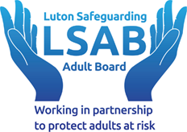

Social Services ID No:

Crime Reference No:

NHS No:

1. Details of the person at risk of harm and abuse (The Relevant Person):

Name:

Address:

Telephone:

Email address:

Date of Birth:

Date of alleged abuse:

Time of alleged abuse:

Known Advocate, Family or Representative - provide contact details:

Responsible or funding authority? (Local authority, Self, NHS, please state all that apply):

GP contact details:

Referrer – date of last contact:

1.1. Gender:

Male

Female

In another way

Prefers not to say

1.2. Ethnicity:

Asian or Asian British

Black, Black British, Caribbean, or African

Mixed or multiple ethnic groups

White

Other ethnic groups

Does the person have care and support needs arising from:

Physical Disability, Frailty |  | Learning Disability
Sensory Impairment |  | Substance/Alcohol Misuse
Mental Health |  | Dementia
Neurodiversity (Autism, Autistic Spectrum, Attention Deficit Hyperactive Disorder, Tourette Syndrome, etc) |  | Medical or Health issues
Other (Please describe):

Communication, consent, and capacity

Preferred language and communication method:
If you are raising this on behalf of the relevant person, have you discussed the concern with them? | Yes |  | No
If not, why not?

Has the Relevant Person given consent? | Yes |  | No
Does the Relevant Person have an impairment of brain? | Yes |  | No
Because of that impairment does the person lack mental capacity to consent to this alert? | Yes |  | No
If ‘yes’, please enter date of mental capacity assessment?

Agencies and professionals involved:
Agency: | Yes/No | Name: | Contact e-mail | Contact Telephone
CQC
Local Authority: Care Quality/Care Standards Team
BLMK/ICB
ELFT P2R (Drug and Alcohol services)
ELFT Community Nursing
ELFT Mental Health Team
CCS/Community Nursing Services
Bedfordshire Police
GP
Bedfordshire Fire and Rescue
DoLS: The Relevant Person Representative
Service/Care Provider
Other: Specify
Other: Specify
Other: Specify

Statutory Type of alleged abuse, maltreatment, or neglect

Discriminatory (including hate crime) |  | Domestic abuse/violence
Emotional/Psychological |  | Financial/Material
Institutional/Organisational |  | Neglect and acts of omission
Physical Abuse |  | Modern Slavery
Self-neglect |  | Sexual Abuse

Additional Type of harm and abuse:
Suicide
Hoarding
Cuckooing
Honour base/forced marriage
Exploitation

Location of suspected abuse, maltreatment, or neglect

Address (Place of alleged abuse):

Own Home |  | Care Home / Nursing Home |  | Public Place |  | Mental Health Inpatient Setting/hospital
Other persons home |  | Supported Accommodation |  | Education/Training/Workplace Establishment |  | Hospital (Medical)
Day Centre/Service |  | Other Health Setting |  | Not know |  | Other
Describe if other:

Description of alleged abuse, maltreatment, or neglect:

Please provide as much detail as possible, including known events leading up to and following the alleged abuse.

Record of injuries

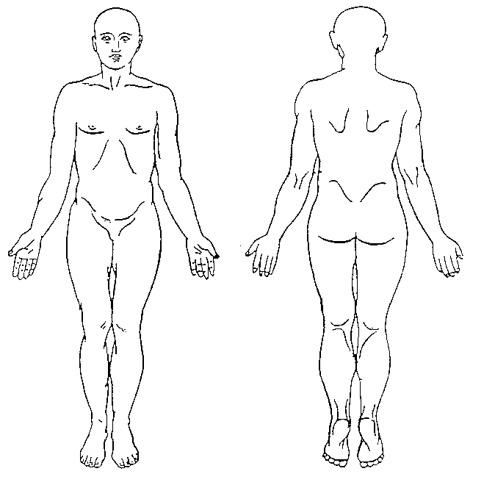  Date: | Observation/Description/Size/colour:  Signature:

3. Action taken

Action taken to minimise immediate risk:
What does the person with care and support needs want to happen, or what is their view of the situation? (Please also consider their representatives if appropriate)
Is there a risk to the adult at risk/ vulnerable adult, a witness or referrer should the person causing harm to know that a referral has been made?
Has there been a delay in reporting this alert (24 hours of the incident)? If so, please state the reasons for this.

Has a manager been alerted? | Yes |  | No
Reported to CQC or other regulatory body? | Yes |  | No
Reported under RIDDOR? | Yes |  | No
Reported to GP or other health care professional? | Yes |  | No
Emergency services alerted? | Yes |  | No

4. About the person causing harm (source of harm)

Name
Address
Telephone:
Date of Birth
Role/Title/relationship to person with care and support needs
Does the person causing harm live with the person with care and support needs?
Ethnicity/Origin?
Preferred language or communication method?
If using services - Funding authority? (Local authority, Self, NHS, please state all that apply)
If an employee, organisation or a paid carer please state name of employer/organisation?
The person causing harm is aware of the referral? | Yes |  | No
Do you consider that the person causing harm has capacity to understand whether their alleged actions were wrong? | Yes |  | No
Do you consider that the person causing harm has capacity to understand the consequences of their alleged actions? | Yes |  | No

Other agencies involved:
Children’s Services |  | Mental Health Services |  | Drug and Alcohol Services |  | Community Nursing
Specialist dementia services |  | Housing or homelessness |  | Domestic abuse victim support |  | Domestic abuse perpetrator support
Advocacy |  | Interpreting |  | Police |  | Other
Other? What? Who?

Details of the person making the referral

Form completed by
Date of last contact with the person at risk
Organisation/agency
Role/relationship to adult at risk/ vulnerable adult
Contact Address
E-mail
Telephone

Signed | Role/Title | Date

6. Who to notify

Please send this alert to the local authority where the alleged abuse took place.
Local Authority | Contact details | Please tick where sent
Luton Borough Council | Email: adultsafeguarding@luton.gov.uk  Phone: 01582 547730/547563
Central Bedfordshire Council | Email: adult.protection@centralbedfordshire.gov.uk  Phone: 0300 300 8122  Fax: 0300 300 8239
Bedford Borough Council | Email: adult.protection@bedford.gov.uk  Phone: 01234 276222  Fax: 01234 276076

https://www.equalityhumanrights.com/en/publication-download/research-report-75-monitoring-equality-developing-gender-identity-question
https://www.ethnicity-facts-figures.service.gov.uk/style-guide/ethnic-groups
Indian, Pakistani, Bangladeshi, Chinese, Any other Asian background
Caribbean, African, Any other Black, Black British, or Caribbean background
White and Black Caribbean, White and Black African, White and Asian, Any other Mixed or multiple ethnic background
English, Welsh, Scottish, Northern Irish or British, Irish Gypsy or Irish Traveller, Roma, Any other White background
Arab, Any other ethnic group

