# Luton’s Strategic Vision for Sport and Physical Activity (2018-22)

*‘A five-year strategy to increase levels of physical activity and maximise the wider benefits of participation in sport and physical activity in Luton’*

## Contents

| 1. **Introduction** | P2 |
| --- | --- |
| 1. **Vision** – what will be different by 2022 | P3-4 |
| 1. **Local Need** and considerations in relation to national advice and strategy | P5-13 |
| 1. **Outcomes** to achieve community benefit and make positive change | P14-36 |
| 1. **Delivery** – how we will do it | P36-38 |
| **6.** **Appendices**   * 1. Overview of delivery groups   2. Stakeholder Consultation   3. Action Plan (separate document)   4. Building on Success – lessons learnt (2013-2017) (separate document) | P38 |

Version: Final (Executive – 08/02/18)

## 1. Introduction

Luton Investment Framework (LIF) is an ambitious 20 year plan for major town-wide transformation to achieve strong and sustainable growth within the town.

Working with our partners, Luton is on schedule to secure £1.5 billion investment to transform the town and create 18,500 quality jobs for local people; driving improvements to health and wellbeing, creating opportunities for residents, raising aspirations and enhancing prosperity across the town.

Improving health and wellbeing is a key strand in the LIF; being physically active is fundamental to leading and maintaining a healthy lifestyle and regular participation in physical activity has multiple benefits to individuals and society; is vital to preventing avoidable ill health and reliance on health and social care services, and to supporting residents to live longer healthier, more active and independent lives.

The wider benefits of sport and physical activity participation are equally important and were identified through the recent national strategy as playing a vital role in supporting the enhancement of skills and education and supporting safer, stronger and more cohesive communities, all of which are the foundation strands of the LIF.

Since the launch of the Strategic Vision for Sport and Physical Activity in 2013 there has been significant progress, many examples of successful innovative projects with strong partnership working, more effective use of our collective resources and the securing of greater levels of external funding, all of which has supported the increases in participation.

While positive progress is to be congratulated, over 25% of Luton’s adult population are physically inactive; a challenging statistic we are committed to change through this strategy. Our vision is to enable more residents in the next 5 years to be more active by creating the capability, opportunity and motivation to take part in sport and physical activity. As a partnership we’re aiming high; by 2022, we want 22,000 people being more physically active in Luton, requiring a shift in behaviour change for at least 10% of Luton’s population.

Strong cross sector partnership with local, national, voluntary and community sector organisations will deliver these ambitious targets. This Luton strategy, co-produced by partners and stakeholders all of whom will play their role in delivering the ambitious outcomes; with the Council coordinating and providing leadership, we will work collectively to achieve the mass shift in behaviour change and participation levels at pace and scale.

We thank our partner organisations for their continued support and look forward to working together over the next five years together driving forward improvement to health and wellbeing and enhanced prosperity across our town.

*Gerry Taylor, Corporate Director for Public Health, Procurement and Commissioning, Luton Council*

## 2. Luton’s Vision – what will be different by 2022

*‘Local people will, regardless of age, background or ability, understand the benefits of maintaining an active lifestyle and have the capability, motivation and unconstrained opportunity to participate in regular physical activity’.*

***Mission ambitions; how we will know this strategy has been achieved?***

By 2022, Luton’s Strategic Vision for Sport and Physical Activity aims to deliver the following ambitions:

1. 22,000 MORE people leading more active lifestyles. To achieve this we will have:

**Fewer inactive people!** Luton currently has 45,900 inactive adults (those not achieving at least 30 minutes activity per week). Luton will have **14,000** fewer inactive residents; our focus will be to engage under-represented groups and those living in areas of greater deprivation.

**More active people!** Wewill encourage and motivate our 25,700 adult residents who are classified as ‘fairlyactive’ to do a little more. We aim to see **8,000** more active Luton adults achieving the recommended 150 minutes activity per week.

1. **Luton’s sport and leisure offer plays a leading role in attracting people to live, visit or work in Luton!** Aligned to the Luton Investment Framework, partners will proactively and collaboratively work to secure further investment into Luton that leads to increased participation levels through an improved active environment and active travel opportunities, well used, safe greenspaces, high quality sporting facilities and a supported voluntary sector including the existing community sports club infrastructure, all of which further will further establish Luton’s reputation as a place known for sporting excellence with a high quality and accessible leisure offer.
2. **Loud, clear and consistent ‘Luton message’ about the benefits of physical activity!** Improve resident’s motivation to participate by building on national insight, campaigns and strategy to support local people to easily understand the benefits of leading an active lifestyle. This clearer understanding of the benefits, along with a greater number of activities to participate within, will help us achieve our aim to reduce the risk of long term health conditions and increase the number of people ageing well and leading independent, active and longer lives, with less reliance on carers, support services, less instances of falls, social isolation and exclusion.
3. **Inclusive and easy access activity for all!** By utilising our existing local and national insight work on the barriers to participation we will encourage new and existing voluntary and community partners in Luton and Bedfordshire to work together to facilitate the availability and access to an increased number of non-traditional or neighbourhood-based places and spaces which allow local residents to take part in sport and physical activity, including most notably school facilities and faith centres.
4. **Focused investment to make the greatest impact** **in improvement of quality of life and reducing health inequalities through addressing the interdependency between physical and mental health.**  Local investment will be focused into local areas where evidence shows there is need and which achieve the greatest health, social and economic impact and strongest return on investment including supporting under-represented groups within our most deprived areas. Emphasis will be on recognising the wider outcomes of physical activity in terms of its role in addressing mental health conditions such as depression and anxiety, including working with IAPT services and through sport, in particular, as a mechanism to destigmatise mental health conditions by creating increased awareness and further understanding. From April 2018, this will be supported by the integrated wellbeing and lifestyle service
5. **Collaboration to combat the rising childhood obesity rates in Luton.** Working alongside parents, local health and education partners we will increase the number and quality of physical activity interventions, co-designed with children and families, specifically in schools and areas and communities where childhood obesity is more prevalent. Our target will be to halt the year on year increases, and highlight the important role that sport and physical activity plays in increasing positive outcomes associated with individual development, health and wellbeing, educational attainment and social development.
6. **Supporting a greater number of pre-and post-natal physical activity interventions to encourage physical activity from birth, contributing towards the reduction of adverse outcomes during pregnancy and infancy and improving school readiness.** There will be more family-based physical activity programmes, resulting in the creation of positive participation habits, increased levels of physically literacy, whilst supporting education of wider early years health considerations for children under five years of age and their parents or carers such as dental care, smoking cessation for expectant mothers and also nutrition and childhood obesity at age 4-5 years.
7. **Supporting young people’s personal and skills development through sport and physical activity.** Increasing levels of resilience, confidence, self-esteem and positive emotional wellbeing, while also focusing on sport, in particular, as a mechanism to support education and skills development of those young people seeking employment, particularly through volunteering, coaching qualifications and apprenticeships.
8. **Safer and Stronger Communities.** Increased levels of physical activity and sport based local interventions will be used to foster improved community cohesion and reduce antisocial behaviour by bringing communities together, breaking down barriers and celebrating, understanding and respecting Luton’s diversity.
9. **More collaborative working between our physical activity and arts and culture providers.** Sport and physical activity will play a key contributing role in supporting Luton’s ambitious aim to become UK City of Culture 2025, including a greater number of sports events with arts and culture activity content and the hosting of a bi-annual physical activity and culture conference in Luton.

## 3. Local need and considerations against national advice and strategy

This section outlines national strategy in terms of definition and guidelines of physical activity and the many benefits of leading an active lifestyle. It also examines the local picture in terms of current activity levels and the challenges faced to improve participation.

**3.1 *The national picture -* *what is physical activity and why is it important?***

Taking part in regular physical activity has a wide range of proven benefits that improves well-being and enhances social and mental health.

According to Public Health England’s 2014 ‘Everybody Active, Every Day’ report, 70% of the current NHS budget is spent on chronic diseases such as diabetes and heart disease and physical inactivity costs the UK an estimated £7.4bn each year (£0.9b to the NHS and an additional £6.5bn to wider society).

Physical activity has a vital role to play in the prevention of ill-health. An inactive person compared to an active person has 38% higher hospital bed days, 5.5% higher GP visits and 13% higher use of specialist services. The NHS Five Year Forward View (2014) states that if the nation fails to get serious about prevention then the recent progress in healthy life expectancy will stall, health inequalities will widen, and the ability to fund beneficial new treatments will be constrained by the need to spend billions of pounds on avoidable illness.

Being active can reduce risk of and help the management of over 20 long-term conditions, most notably diabetes, cancer, dementia, strokes, heart disease and depression. According to Sport England’s 2017 Active Lives Survey, only 60.6% of adults are physically active as defined by the Chief Medical Officer recommendation of 150 minutes participation each week.

The 2015 Department for Digital, Culture, Media and Sport (DCMS) ‘Sporting Future: a new strategy for an active nation’ summarises the evidence for sport’s impact on physical and mental health, building social capital, educational attainment and employability and economic growth is well-established. Beyond simply participating, there are five areas where sport and physical activity can make the greatest contribution:

1. Physical Wellbeing
2. Mental Wellbeing
3. Individual Development
4. Social and Community Development
5. Economic Development

Being aware of patterns of behaviour enables a better understanding of the main factors that influence participation. These sit within the behaviour change model used by Sport England which identifies five key stages of behaviour that define and shape interventions and programmes funded in future.

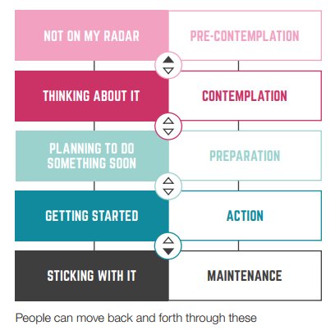

*Figure 1 - Behaviour change model, Sport England, Towards an Active Nation (2016)*

Further focus on the importance of behavioural change has been developed by the University of Bedfordshire (UOB) who investigated how Behavioural Science can support the further understanding of barriers to participation in sport and physical activity, in terms of *why* people may be a certain mind-set and *how* to change this.

***Being physically active – the common language and definitions***

The Chief Medical Officer definitions used in their strategy are:

* An **inactive** person as someone who, over the course of a week, does not achieve a total of 30 moderate intensity equivalent (MIE) minutes of physical activity.
* An **active** person as someone who, over the course of a week, achieves a total of over 150 moderate intensity equivalent (MIE) minutes of physical activity.
* A person who does between 30 and 150 moderate intensity equivalent (MIE) minutes of physical activity is classified as **fairly active**

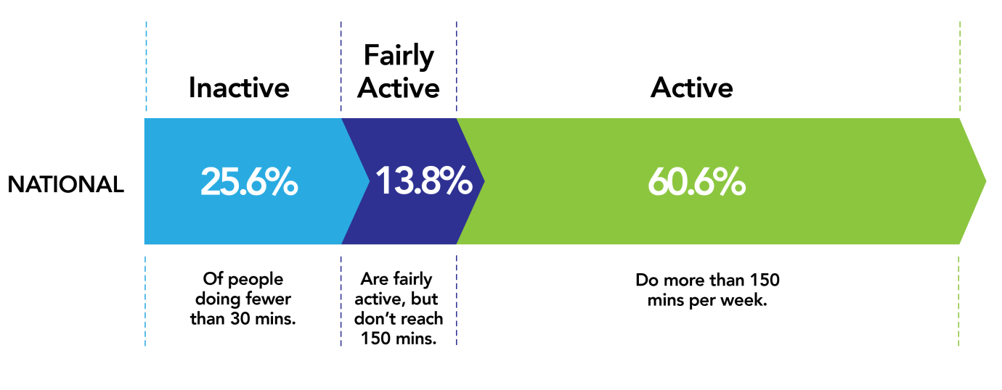

*Figure 2 – Overview of national participation (+16 years), Active Lives Survey, 2017*

Low levels of physical activity is an issue across the life course, including amongst children and young people, who have different recommended levels of activity that should be undertaken, as can be seen from the Public Health England infographics below.

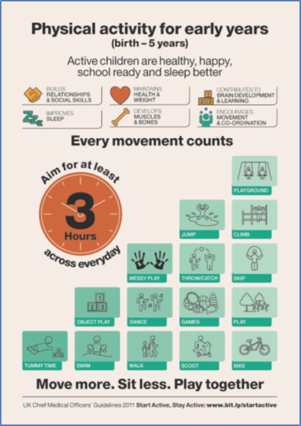Images of CMO physical activity infographics for young people and early years

*Figure 3 – Images of CMO physical activity infographics for young people and early years*

The DCMS and Sport England have more recently placed greater emphasis on tackling physical inactivity and recognise that the biggest gains and best value for public investment is found in addressing the people who are least active. According to Sport England, 1 in 6 people in the UK die as a result of being physically inactive and this is the same number of people who die from smoking. For people who are classified as inactive, the lack of activity is a principle behavioural risk factor for long term conditions including heart disease, stroke, breast and colon cancers and diabetes.

***3.2 The Luton Picture: the local participation challenge!***

Luton has wide and challenging characteristics that to varying degrees shape and impact on the health, wellbeing, activity levels, prosperity and overall quality of life of residents. Listed below are ten influencing factors regarding participation levels in Luton -

1. Luton is a super-diverse town and is one of just three plural[1] locations in England, the others being Leicester and Slough. The town has large numbers of BAME (black, Asian, and minority ethnic) communities and since 2011 has also seen notable increases in the establishment of Polish and Romanian communities. There are over 120 languages spoken within the town. According to a 2017 Luton Population Change Report, Luton continues to change and it is estimated that approximately 30 to 50 % of the current population were either not born or not living in Luton at the time of the 2011 Census.
2. Life expectancy, for both males and females, is lower than the regional and national averages, but comparable with its statistical neighbours. A male is expected to live 2 years less than elsewhere in the East of England, with women slightly better at 1.5 years (2009-2013). These figures are significantly worse in areas of highest deprivation at 8.9 and 6.9 years respectively.

Healthy life expectancy (HLE) is the measure of the average number of years a person would expect to live in good health. For males 22.4% of their life is spent not in good health compared with 20.3% nationally. For females 25.7% of their life is spent not in good health compared with 23.1% nationally (2011 Census).

1. The Index of Multiple Deprivation (IMD 2015)2 ranks Luton as the 59th (of 326) most deprived local authority (one being most deprived). In 2010, Luton was ranked as the 69th most deprived local authority and in 2007 as the 87th, indicating that it is becoming relatively more deprived in comparison to other England local authorities. Luton has nine output areas in the top ten per cent most deprived areas in the country located within Northwell (3), Farley(2) , South (2) Biscot (1) and Dallow (1) wards.

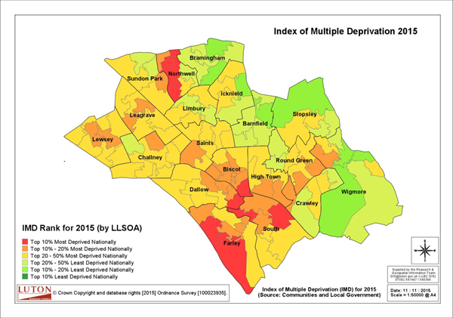

*Figure 4 – Luton Index of Multiple Deprivation (IMD) 2015*

1. Luton is seeing an increase in its ageing population. The 55 plus age group is projected to increase by 11.5% from 2014-2020. At the same time the younger population aged 5-9 group (Years 1 – 6 Primary school age) is projected to increase by 21.8%.
2. According to Luton’s Joint Strategic Needs Assessment (2015), the main diseases that contribute to the difference in life expectancy between wards in Luton are circulatory (coronary heart disease & stroke), cancer (lung) and respiratory (COPD, pneumonia).
3. Childhood Obesity (including overweight) rates are in line with national averages at Year R, however, obesity levels in children at Year 6 (aged 11) considered obese are relatively high with 24.7% against a national rate of 19.8%. In reception year where prevalence of overweight children is below the national average, however the percentage of obese children is higher. This is a significant issue as habits are likely to track from childhood to adulthood.
4. Despite the recent £26M investment in its world class ‘Inspire: Luton Sports Village’ leisure facility, Luton does not have as many sports and leisure spaces as comparable areas and in some cases significantly less, for example, in 2015 Luton had 298 facilities, compared to Bradford (813), Hillingdon (670), Redbridge (473), Sandwell (428) and Wolverhampton (376), with only Slough (193) having fewer facilities.
5. Luton has 28 sports club that are accredited to Clubmark or equivalent level. A number of them are long established, with strong reputations locally, regionally, and in some cases nationally for the provision of excellent quality, accessible sporting opportunities for all. Many have thriving youth sections that provide quality opportunities in a safe and nurturing environment. Much of this work is underpinned by volunteers who secure accredited qualifications through their National Governing Bodies and County Sport Partnership in their own time and at their clubs expense. This network provides an invaluable introduction and re-introduction to sport and physical activity for the population of Luton.
6. Luton is a densely populated town and in comparison to the CIPFA nearest neighbours, has the highest population density, at 49.5 persons per hectare. The comparative high density population and low total greenbelt provides a challenge in providing areas for recreation. However, park space is well used for exercise with Natural England suggesting that 20.7% of the population use outdoor space for exercise/ health reasons, which is higher than England average at 17.9%
7. The town’s topography provides some challenges, particularly with regards to travel on foot and bike, whereby suitable cycle and walking routes are currently underutilised and promoted. In addition, significant pressures on housing (over 10,000 people on the Council’s housing waiting list) and therefore the need to build on green-land, placing existing facilities and space for sport and recreation under pressure.

**How active is Luton’s population?**

27.8% of the adult population are classified as inactive (see figure 5) and the costs associated with these levels of inactivity are significant, with the direct and indirect cost last estimated in 2014 by UK Active in their ‘Turning the Tide of Inactivity’ publication as £23,522,034 per annum. In terms of direct health costs regarding specific diseases and relating to physical inactivity, were last estimated in 2013/14 (see table 1)

| *Total costs (expenditure) £’s* |  |  |  |  |  |
| --- | --- | --- | --- | --- | --- |
| *Cancer lower GI* | *Cancer breast* | *Diabetes* | *Coronary heart disease* | *Cerebrovascular disease* | *Total Expenditure* |
| *156,601* | *251,687* | *571,437* | *425,434* | *168,167* | *1,573,326* |

*Table 1 – Direct health (NHS) costs of physical inactivity in Luton (2013/14) Source: Physical inactivity: economic costs to NHS clinical commissioning groups (PHE, May 2016)*

In addition to overall physical activity levels, Sport England, since 2005, have also measured sport participation rates in the shape of adult (16+) participation rates of ‘at least one sport session of moderate intensity of 30 minutes per week’. Since 2013 Luton figures for sport participation have risen from 28.1% to 34%, slightly below regional and national rates (36%).

Introduced in 2016, Sport England’s ‘Active Lives Survey’ (ALS) is an adult survey which measures sport and activity behaviours across England. In terms of physical inactivity, the 2017 ALS suggests that Luton has more inactive people than national average (see figure 5)

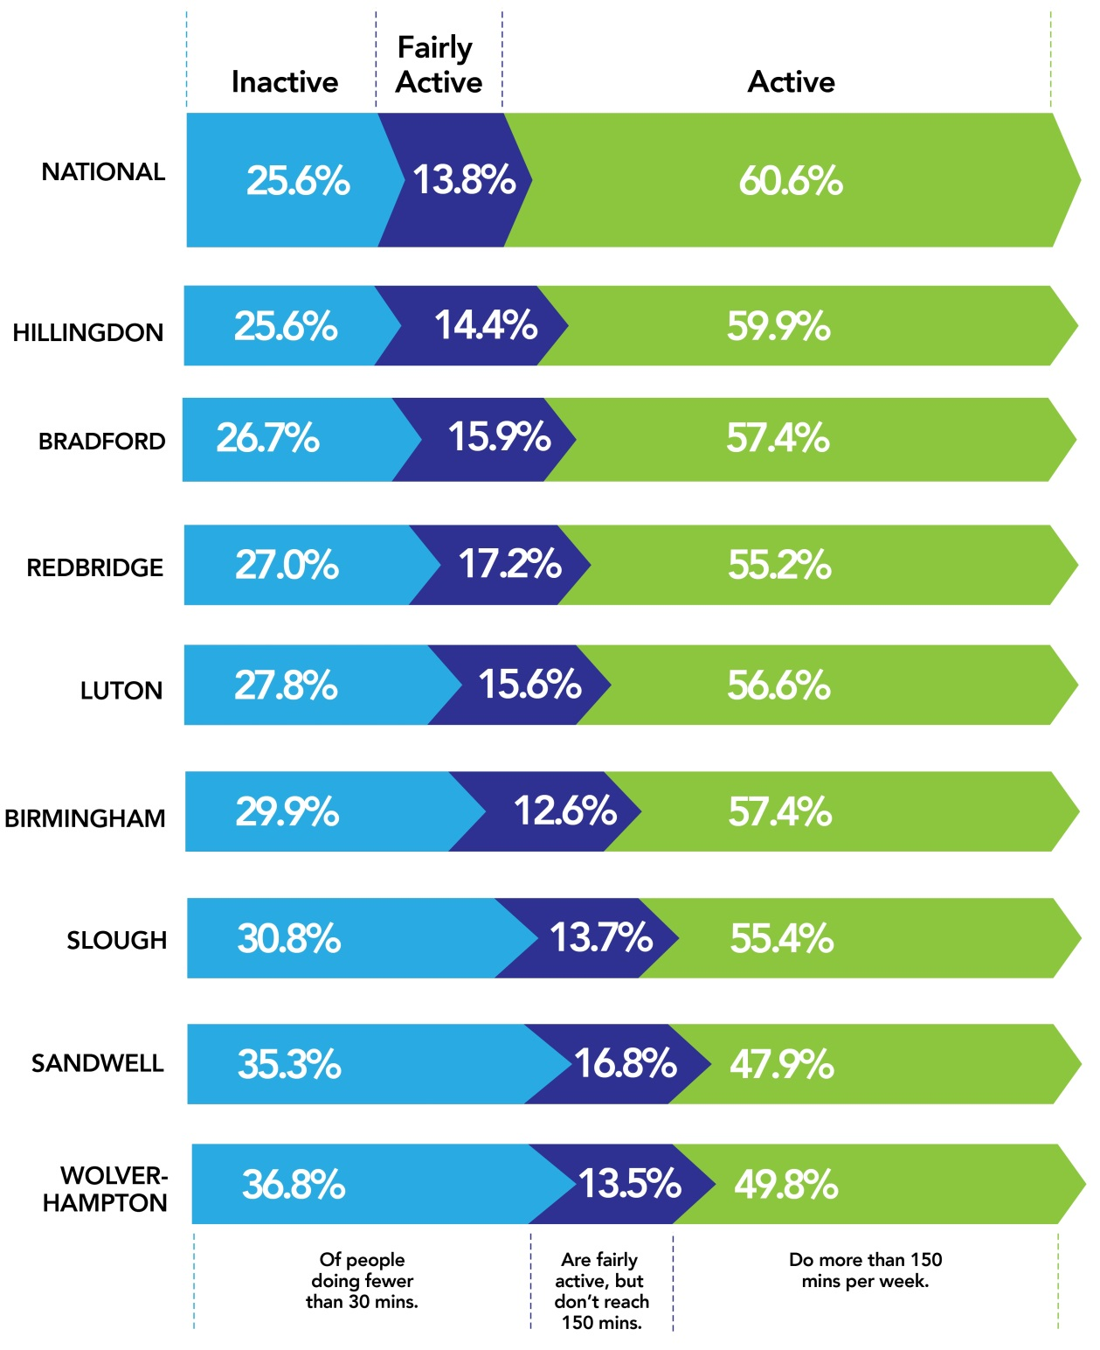

*Figure 5 – Luton participation levels vs statistic neighbours (Active Lives Survey, 2017)*

***Local considerations for boosting participation levels***

**Socio-economic status** - Luton’s socio-economic make-up plays an important part in determining levels of inactivity with Active Lives Survey data indicating nationally that inactivity rates within the long term unemployed or ‘never worked’ sector (Socio-economic classification ‘SEC’ 8) are 37% compared with managerial, administrative or professional (SEC1) at 17%. Luton, when compared with regional and national average, has 9.9% of the population within SEC8 category, compared with 5.6% for England and Wales.

**Gender** - According to Sport England, the gender mix for an area will also play an important part in determining likely levels of inactivity. Luton’s female population participation rates remain lower than regional and national rates with 24% of women participating in sport, as compared with 31.9% nationally. In addition, Sport England in its 2017 ‘Spotlight on Gender’ report suggests that nationally there is a 10% gap between ‘active’ males and females of Asian and black backgrounds and that it’s important to understand the role ethnic and cultural backgrounds can play with regards to barriers to participation.

**Ethnicity** - In terms of BAME participation in sport and physical activity, the data in figure 6 demonstrates a clear difference in activity levels by ethnicity with people from White British, White other and Mixed backgrounds having higher activity levels than South Asian, Black, Chinese and Other ethnic backgrounds. This national data is supported by insight from a local research project undertaken in Luton by Sporting Equals, a national partner of Sport England and advisors to the DCMS, which was completed in 2016. The research aimed to understand the barriers to participation, particularly in terms of South Asian communities and identified a number of challenges to help engage BAME communities more routinely in sport and physical activity along with several recommendations to consider, such as:

* Focussing on the creative use of open air spaces for the whole community
* Providing more female volunteers and coaches for all-female sport
* Understanding the cultural needs of the community, especially women and girls
* Better engagement with the young population through social media

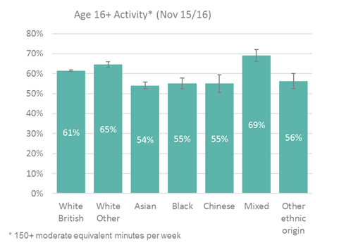

*Figure 6 – National participation statistics by ethnicity (Towards an Active Nation, Sport England, 2017)*

**Early Years** – In line with its changing remit of working with children and young people from five upwards, Sport England has recently launched ‘Active Lives: Children and Young People’ which will provide further data on how children engage with sport and physical activity. The survey results are due out in early 2019 and will help to further shape Luton’s priorities and subsequent actions for this target group. The ‘ME TIME Family Flying Start programme has provided learning to build on in this area and more information can be found on pages 36.

**School-aged Children** – The annual SHEU (School and Students Health Education Unit) Survey data in 2016 indicates a clear decline in perceived fitness, actual exercise levels and enjoyment of exercise through the key stages with notable feedback including:

* Pupils described themselves as ‘unfit’ or ‘very unfit’ - Primary 7%, Secondary 17%, Year 10 girls 25%
* Pupils responded that they are ‘fit’ or ‘very fit’ - Primary 68%, Secondary 39%, Year 10 girls 23%
* Pupils responded that they exercised enough to breathe harder at least three times in the week before the survey - Primary 73%, Secondary 58%, Year 10 girls 36%
* Pupils responded that they enjoy physical activities ‘quite a lot’ or ‘a lot’ - Primary 82%, Secondary 72%, Year 10 girls 54%

Year 10 girls showed the largest decline with key shifts in behaviour change as displayed between Year 8 and Year 10, whereby there is a significant change in both girls enjoyment and participation levels, as demonstrated in table 2

|  |  |  |
| --- | --- | --- |
| ***Indicator*** | **Year 8 (girls)** | **Year 10 (girls)** |
| Percentage answering that they enjoy physical activities ‘quite a lot’ or ‘a lot’ | 71% | 54% |
| Percentage answering that they did physical activity on at least three days in the week before the survey. | 65% | 40% |
| Percentage answering they got out of breath  and/ or sweaty while doing physical activity for an hour or more on at least three days in the week. | 30% | 19% |

*Table 2 – 2016 SHEU Survey questions on physical activity for Years 8 and 10 girls*

In addition to physical activity and sport, the SHEU survey also reports on mental health considerations with worry and anxiety levels in young people regarding a range of issues such as bullying, health, relationships and exams, with results indicating high levels of worry and anxiety, particularly in year 10 girls. This is particularly relevant given the evidence base which suggests that participation in sport and physical activity can have positive effect in addressing stress and anxiety levels.

**Young People** – In 2014 a Luton Youth Insight Project (LYIP) was devised by the University of Bedfordshire Business School (UBBS), Luton Council, Sport England and Active Luton. The purpose of the project was to gather information on the attitudes and behaviours of young people between the ages of 16-25 years around physical activity in Luton. Over 520 young people were engaged through a range of methods such as surveys, face to face interviews and focus groups with the headline results indicating:

* The words ‘Physical activity’ predominantly meant exercise, sport and fitness
* Gym (1st), walking (2nd) and Jogging/running (3rd) were the most participated in activities
* Health (1st), fitness (2nd) and mental health (3rd) were the main motivating factors
* The key barrier to participation was time, followed by young people perceiving themselves as too lazy, with only 2% of participants citing cost as a barrier

**Disabled People** – Whilst there isn’t a great deal of data available locally around participation levels amongst people with disabilities, national figures by Sport England show that people with a disability are 43% more likely to be inactive than those without. Figures for inactivity climb with the number of impairments per individual with 22% of people with 1 impairment being physical inactive, compared with 41% and 51% for people with 2 impairments or 3+ impairments respectively. Work within Luton has begun to address the gap in local data, with several forums and workshops held to ascertain need, gaps in provision and to provide education around working with an individual with a disability.

**Age** – According to Sport England’s Active People Survey, the proportion of those reaching 150 minutes of physical activity a week generally decreases with age. People aged 75-84 are half as likely to be active as 16-24 year olds. Inactivity levels increase with age, with the sharpest increase seen between the ages of 75 and 84 (48%) and those aged 85+ (71%).

**LGBT** – Local data on physical activity behaviours is scarce, however feedback from service users indicates that key barriers to participation include lack of self-awareness, fear of homophobia, lack of trans awareness and being forced to gender identify. Further work will be undertaken alongside local organisation, LGBT Links, in order to develop understanding of these barriers and how they can be overcome by working with service delivery providers.

**Volunteering** – Locally, it is anecdotally recognised that the volunteer sector underpins much of the excellent work undertaken within Luton’s existing community sports club infrastructure, with sports clubs often providing an invaluable introduction to sport and physical activity for many. Local data regarding the number of sport and physical activity volunteers is not readily available, however, the 2017 Active Lives Survey indicates that men are much more likely to volunteer in sport and activity than women, and this contrasts to volunteering in general, where men and women volunteer in equal numbers. In sport, male volunteers are more likely to hold positions of influence as coaches, officials and committee members. Key Statistics on sport volunteering include:

* 4 million (60%) of adult (16+) volunteers are male, and 2.7 million (40%) are female; a gender gap of 1.3 million (20%)
* People from lower socio-economic backgrounds make up 31% of the population, but only 10% of volunteers
* Disabled people make up 21% of the population but only 11% of volunteers.

***Priority groups for increasing participation in Luton***

Certain groups are significantly less likely to play sport and be physically active than the population in general. Whilst there will always be a universal sport and physical activity offer to the general public of Luton, there needs to be a targeted approach to working with certain population groups to prioritise increasing participation including

**Overarching groups**

* People classified as physically ‘Inactive’
* People from lower socio-economic backgrounds and higher areas of social deprivation (with a focus on the 20% most deprived wards)

**Secondary groups**

* Women (particularly BAME communities) and Girls (aged 14-16)
* Primary school aged children (aged 5-10)
* Adolescents and young men (aged 16-25) particularly those who are classified as ‘Not in Work, Education or Employment’ and/or engaged in anti-social activity
* Disabled people (with a further focus on those with multiple impairments)
* Older adults at higher risk of deteriorating frailty levels and developing long term health conditions such as diabetes, cancer, dementia, strokes, heart disease and mental health.

## **4. Outcomes to achieve positive change**

From consultation with local partners and utilising the national strategic framework for physical activity, four strategy themes have been identified together with a number of individual focus areas, aiming to promote a whole systems approach to delivery in Luton.

| 4.1 | **Place Making and Community** (overarching theme) – creating a social movement for an active society. |
| --- | --- |
| 4.2 | **Luton’s Active Environment** – creating the appropriate natural and built environment to facilitate active lives. |
| 4.3 | **Tackling Physical Inactivity and Improving Mental Wellbeing** – supporting the most in need to get the right start in life and live active, healthy and longer lives. |
| 4.4 | **Sport and Skills Development** - to help the ‘active stay active’ and deliver the wider social, individual and economic development outcomes of sport participation. |

*Table 3 – Strategy themes and focus areas*

**4.1 Place Making and Community – creating a social movement for an active society**

Public Health England’s (PHE) 2014 report ‘Everybody Active, Every Day’ stated that ‘a culture change is required so being active every day is the social norm in every community and generation’. This will involve sustained activity at every level of society; mobilising a range of diverse stakeholders with visible leadership across all sectors.

To create population level behaviour change, local people need the capability, opportunity and motivation to participate. Leadership in Luton is required to provide clear and consistent messages about the benefits of participation, helping to create more accessible and population-relevant participation opportunities and ensuring that sport and physical activity contributes to the wider aims set out in the Luton Investment Framework.

| ***Outcome 1: Improved messaging that is clear, consistent and simplified about the benefits of participation.*** |
| --- |

**Activity:**Utilise national messaging to promote participation messages and national campaigns such as ‘One You’, ‘Ten Minute Shake Up’ and ‘This Girl Can’ in an appropriate format tailored to Luton residents, using social media, as appropriate. Coordinate this work through the Luton Health and Wellbeing Communications Group – a partnership of health providers in Luton.

**Rationale:** Sport England and PHE are currently undertaking an exercise to align health messaging and insight, recognising that there are often too many, and sometimes mixed, messages regarding the benefits of participation in physical activity. Local providers have a role to play in promoting a Luton-appropriate ‘common language’ to residents regarding the benefits of participation in way that resonates with Luton’s diverse population and, in turn, acts as a way of motivating more people to take part in sport and physical activity. Technology allows us to reach further, and faster, and we advocate use social media especially to engage young audiences.

| ***Outcome 2: Easy access to sport and physical activity opportunities through population appropriate marketing and communication.*** |
| --- |

**Activity:** Work alongside sport and physical activity providers to ensure services are clearly embedded within the ‘Luton Directory’, providing local residents with a single point of access to services, including physical activity.

Encourage local partners to employ a person-centred approach to marketing and communications, including the creation and utilisation of motivational case studies reflecting and celebrating the town’s diversity and provide real stories and role models to inspire others to participate.

**Rationale:** Local residents need to be able to locate and access activities quickly and easily. Insight suggests that one of the key barriers to participation is residents’ understanding of what activities are already taking place within the town. We will advocate the ‘People Like Me’ approach with marketing and communications focussing on words like ‘me’, ‘our’ and ‘your’ with images of real local people from a wide range of communities. Case studies of local people will provide the narrative that builds on imagery to further motivate and break down barriers, real or perceived, around personal capability to take part in physical activity.

| ***Outcome 3: Greater support provided to the VCS including community sports clubs, through community development approaches to facilitate a knowledgeable, sustainable and resilient physical activity sector*** |
| --- |

**Activity:** Further develop the Community Activity Network (CAN) and Luton Sports Network to support VCS groups and clubs, including seeking external funding to create a Luton Physical Activity Fund for VCS groups to bid for funding for local physical activity projects delivered in non-traditional settings and aimed at under-represented groups. The services of the County Sports Partnership and National Governing Bodies should be pro-actively sought to provide support for the future development of community sports clubs, including support with funding applications; providing opportunities for clubs to secure funding from national programmes to be delivered locally; development of the volunteer workforce and education regarding engagement with and retention of members.

Utilise the CAN to support smaller groups and organisations in the shape of networking, funding advice, support on governance and sustainability. Produce a map of activity within neighbourhood settings to highlight where the current gaps in provision exist and ensure that community based sport and activity sessions are promoted more widely.

**Rationale:** Sport England’s 2016 ‘Towards an Active Nation’ strategy indicated that in order to increase participation levels a broad range of partners are required as part of a whole systems approach which the involvement of the voluntary and community sector is vital. Local insight has also highlighted the importance of utilising non-traditional or informal leisure settings in providing accessible activity opportunities at a neighbourhood level.

| ***Outcome 4: Defining Luton as an ‘Active Town’ by utilising sport and physical activity to enhance the town’s image as an excellent place to live, work and visit*** |
| --- |

**Activity:** Greater promotion and recognition of residents achieving regional and national sporting success and the continuation of seed funding via Luton Sports Network for aspiring young Luton athletes.

Greater promotion and increasing the number of locally held, high profile, national and regional sports events focused on promoting positive outcomes in terms of participation levels and promoting Luton as a an excellent place to live, work and visit. This includes a focus on events and activities within the town centre in line with supporting aims of the Luton Business Improvement District (BID)

**Rationale:** Luton’s Investment Framework presents a vision for investment into Luton up to 2035 with health and wellbeing being fundamental to the economic prosperity of the town. Physical activity and the broader leisure offer for the town are significant components.

Through its ‘Sporting Future’ report, the DCMS notes that as well as developing individuals, sport can help build stronger communities by bringing people from different backgrounds together, promoting their sense of wellbeing and positivity about the place they live whilst building social capital and trust.

Similarly, a high quality sporting offer which generates national and regional success (on an individual and team level) can improve civic pride and stimulate interest in people to try out a sport or becoming physically active. Supporting young talent and aspiring sports people is a local priority as is promoting the sporting success stories of local people. This high quality sporting offer includes the hosting and promotion of national and regional sports events, such as the annual Love Luton Half Marathon, which not only seek to inspire others to participate, but to also ensure that sport plays its part in enhancing the towns positive image.

| ***Outcome 5: Embedding sport and physical activity in all that we do locally (i.e. professionals and policy)*** |
| --- |

**Activity:** PHE Clinical and Nurse Champion leads to host training sessions in Luton with health professionals in primary and secondary care e.g. doctors, nurses.

Relaunch Making Every Contact Count training with 500 people being trained annually, including VCS and community leaders.

**Rationale:** Making Every Contact Count (MECC) is an approach to behaviour change that utilises millions of day to day actions that organisations and people will have with other people to support them into making positive changes with their physical and mental wellbeing. This includes ensuring health care professionals have the skills to deliver brief conversations (advice) on physical activity to patients to make every contact count.

According to the PHE 2016 report ‘Local health and care planning: menu of preventative interventions’, health care professionals lack training in delivering effective behaviour change advice to patients. PHE is now training healthcare professionals, via Physical Activity Clinical Champions, to provide physical activity advice. Clinical champions provide peer-to-peer teaching to primary, secondary and community care professionals to integrate brief advice into routine care to make every contact count.

**4.2 Active environment – creating the appropriate (natural and built) environment to facilitate active lives**

Luton has some excellent sport and physical activity facilities including the £26m Inspire: Luton Sports Village and its many greenspaces, including 6 Green Flag parks.

Providing the right environment for sport and physical activity to take place is of huge importance, as the quality, quantity and appropriateness of the natural and built sporting infrastructure of an area will have a direct bearing on participation levels, but can also bring additional benefits such as reduced traffic congestion, increased community cohesion and social interaction.

With a growing population and continued financial pressures faced by the Local Authority and partner organisations, Luton’s Playing Pitch Strategy (2014-21) and Indoor Sports Facilities Strategy (2015-21) provide guidance on maintaining, protecting and best use of existing space, including developing creative solutions for ongoing use and sustainability of community facilities via the Community Asset Transfer model, whilst recent national strategy promote hub models, whereby a focus on multi-sport centres and co-location with other service provision (such as GP’s and libraries), as positive models of ensuring sustainability and increased usage.

Through its 2017 Cycling and Walking Investment Strategy, the government recognises the importance of Active Travel and integrating physical activity, specifically walking and cycling into resident’s everyday lives. Luton has benefited from government funding to improve Active Travel; these additional resources will play a significant role in increasing the levels of active people.

Inward investment remains a strategic focus and Luton’s Investment Framework and current Strategic Vision for Sport and Physical Activity have provided a successful framework to support attracting ongoing investment in sports facilities and programmes within the town.

| ***Outcome 6: Maintaining existing and developing high quality, sustainable spaces for sport and physical activity*** |
| --- |

**Activity:** Continued delivery of associated priorities and actions identified in Luton’s Playing Pitch and Indoor Sports Facilities strategies, including the completion of a Sport Pitch Feasibility Study in 2018 and subsequent recommendations for the development of key future facilities to encourage increased levels of participation in sport and physical activity.

**Rationale:** Working with a range of local partners, Luton Council launched its Playing Pitch Strategy (2014) and Indoor Sports Facilities Strategy (2015). These strategies seek to provide a clear framework for the maintenance and improvement of existing outdoor and indoor sports facilities and ancillary facilities until 2021. Specifically these strategies will:

* Protect and enhance levels of indoor and outdoor sports facilities
* Address issues of quality and management with regard to facility provision
* Maximise access to all indoor and outdoor facilities, in particular educational facilities
* Maximise investment into indoor and outdoor sports facilities

These strategies have been successful in supporting local organisations, along with team BEDS&LUTON to attract significant external funding for the improvement of sports facilities

|  |  |  |  |
| --- | --- | --- | --- |
| **Club/Organisation** | **Venue** | **Type of project** | **Amount** |
| Luton Town Sports Club | Wardown Park | Facility development – Phase 1 | £50,000 |
| Luton & Dunstable Squash Club | Lewsey Sports Park | Infrastructure development following opening of ands relocation to Lewsey Sports Park | £10,000 |
| Lewsey Boxing Club | Lewsey Sports Park | Infrastructure developments following opening of and relocation to Lewsey Sports Park | £10,000 |
| Luton Town Sports Club | Wardown Park | Facility development – Phase 2 | £21,792 |
| Lutonian CC | Lower Wardown Park | Infrastructure development following return to Luton – Phase 1 | £8,950 |
| Luton Town & Indians Cricket Club | Wardown Park | Infrastructure development to support premises development/improvements | £15,360 |
| Salto Foundation | Salto Gymnastics Club | Premises development | £50,000 |
| Lutonian CC | Lower Wardown Park | Infrastructure development – Phase 2 | £9,929 |
| Luton Town Sports Club | Wardown Park | Facility development – Phase 3 | £90,323 |
| Luton Council | Beech Hill Primary. | Development of two x MUGA’s with floodlighting | £132,438 |
| Stockwood Park RUFC | Stockwood Park RUFC | New floodlighting and upgrade to social facilities | £62,661 |
| Luton Town Sports Club | Wardown Park | Protecting Playing Fields to upgrade the square and level off | £65,000 |
| Total funding |  |  | **£526,453** |

*Table 4 – 2015-17 external funding received for sporting infrastructure improvements*

Recent local investment in leisure facilities include making physical improvements to the towns key leisure facilities at Inspire, Lewsey and Lea Manor centres to improve overall accessibility and customer experience by focusing investment on areas which aim to support the removal of barriers to participation, such as those improvements taking into account cultural sensitivities.

Luton has also seen other notable investment in the shape of three new sport pavilions at Stopsley Common, an artificial football pitch at Lea Manor School and a range of Outdoor Fitness Equipment in Luton’s District and Neighbourhood Parks.

In 2017, Luton Council successfully applied for Sport England funding to develop a sports pitch feasibility study, working alongside local partners and governing bodies of the key sports of cricket, football and hockey. The outcome of the feasibility study will enable the Council and partners to further understand how they can address the key pitch demands and as identified through the Playing Pitch Strategy including particularly additional cricket hub and football stadia 3G provision.

The action plans associated with the Playing Pitch and Indoor Sport Facilities strategies will continue to be delivered until 2021 and address the priorities of community asset transfer of facilities, community access to schools and supporting the development of new and/or improved infrastructure to support sport and physical activity including and sustained maintenance of current assets.

| ***Outcome 7: Improving access to Active Recreation with in local parks*** |
| --- |

**Activity**: To achieve Green Flag Awards for all District level parks in Luton and seek opportunities to improve facilities (including play) in District and Neighbourhood parks that encourage active participation in sport and physical activity.

**Rationale:** Luton’s District and Neighbourhood parks are valued by local families and communities and provide opportunities for leisure, relaxation and exercise. Local experience has shown that increased footfall in the local park is linked closely to the perceived levels of supervision, the level of circulation and through-route paths and the quality of facilities, including play provision.

Parks that are well used by the local community are perceived as being safe however the connectivity between parks and other local community facilities such as community centres, schools and local shops is also important in encouraging local people out doors.

The Department for Communities and Local Government (DCLG) support the Green Flag Park criteria, as the national quality standard for parks. The assessment criteria include measures relating to cleanliness, maintenance, accessibility, community use and appropriateness of facilities to meet the needs of users.

| ***Outcome 8: Ensuring local planning policy reflects the needs of sport and physical activity*** |
| --- |

**Activity:** The Council will refer to the Local Plan and its supporting evidence base in consultation with appropriate agencies and stakeholders when preparing or commenting on development proposals and also aim to utilise expertise from the Sporting Environment Group, Public Health and ecology service as appropriate.

**Rationale:** Luton has recently revised the Local Plan. The National Planning Policy Framework (NPPF) provides the basis for plan-making and decision-taking across the country. Two of its directions are:

‘To deliver the social, recreational and cultural facilities and services the community needs, planning policies and decisions should:

* Plan positively for the provision and use of shared space, community facilities (such as local shops, meeting places, sports venues, cultural buildings, public houses and places of worship) and other local services to enhance the sustainability of communities and residential environments…
* Ensure that established shops, facilities and services are able to develop and modernise in a way that is sustainable and retained for the benefit of the community…’ (paragraph 70)

‘Existing open space, sports and recreational buildings and land, including playing fields, should not be built on unless:

* An assessment has been undertaken which has clearly shown the open space, buildings or land to be surplus to requirements; or
* The loss resulting from the proposed development would be replaced by equivalent or better provision in terms of quantity and quality in a suitable location; or
* The development is for alternative sports and recreational provision, the needs for which clearly outweigh the loss.’ (paragraph 74)

NPPF Paragraph 17 sets out 12 core principles, which include that planning should ‘take account of and support local strategies to improve health, social and cultural wellbeing for all, and deliver sufficient community and cultural facilities and services to meet local needs’.

The Local Plan evidence base includes a focus on a Green Infrastructure Plan for Luton, Green Space Strategy Review and the Strategic Vision for Sport and Physical Activity. The objectives of all of these documents are therefore material considerations in planning applications.

In terms of local planning policy in Luton, the Luton Local Plan is the starting point for the determination of planning applications. The Council has recently prepared new planning policies in line with the directions of the NPPF, which have undergone formal examination and were adopted on 7th November 2017 as the Luton Local Plan 2011-2031.

To support informal activity, the plan identifies and allocates land that supports a network of Neighbourhood and District parks.  This resource is complemented by another network of publicly accessible wildlife sites. The plans seek to protect existing open spaces, sports and leisure facilities.  If the redevelopment of existing facilities to other uses is necessary, the plan states that equivalent or better facilities are re-provided in a suitable location.

| ***Outcome 9: Increased levels of Community Asset Transfer (CAT) of sporting facilities*** |
| --- |

**Activity:** Support clubs wishing to express an interest in Community Asset Transfer, with the aim of transferring facilities where appropriate and in line with community usage of parks and greenspaces and supporting a more financially efficient Council.

**Rationale:** The local authority and local partners has supported several successful examples of CAT with Cricket organisations (as per section 5.7) and by working with sports clubs and sport National Governing Bodies, now has a template for CAT to support groups to be able to manage and maintain their own sporting facilities.

Community Asset Transfer provides a solution to reduce the financial burden on the Council related to the ongoing repairs and maintenance obligation to its buildings, whilst providing voluntary and community sector organisations, which are able to develop robust business cases, the opportunity to acquire assets and deliver sustainable services to the community.

| ***Outcome 10: Increasing levels of people choosing Active Travel as their choice of transport*** |
| --- |

**Activity:** To substantially improve the Active Travel offer in Luton though dedicated resource and delivery of ‘Sustainable Travel Access to Railway Stations’ (STARS) project and the associated marketing, delivery and monitoring plans. This will include the production of an Active Travel Plan for Luton.

**Rationale:** Active Travel encourages getting from one place to another by walking or cycling. NICE guidelines for walking and cycling, (2013) promote walking as the most likely way all adults can achieve the recommended levels of daily physical activity as part of their normal routine providing benefits which are more likely to be long term and sustainable. Active travel initiatives are often more accessible and cost effective than other exercise and leisure pursuits; a significant factor given Luton’s socio-economic population mix.

In addition to becoming physically active there are a range of benefits from promoting Active Travel including increased social interaction; improved air quality through lower traffic volumes; supporting local businesses and promoting a vibrant town centre; providing a high-quality and appealing public realm.

Luton Council is proactively addressing Active Travel and has a team of officers dedicated to promoting and increasing the number of residents travelling by foot or bicycle especially during peak hours by working in partnership with the business community, railway stations, and schools across the borough, including with stakeholders such as Govia, University of Bedfordshire, L & D Hospital, London Luton Airport, Vauxhall and the Mall.

Luton Council along with Central Bedfordshire and Bedford Borough Councils has successfully bid for ‘Access Funding’ to undertake a project to promote both active and sustainable travel to and around the main train stations in Bedfordshire, including all three Luton stations. The three-year project STARS, aims to increase cycling activity, reverse the decline in walking activity and increase the percentage of children aged 5 – 10 that usually walk to school.

The STARS project will address and aim to deliver increased Active Travel though:

* Marketing and Communication plans to raise the profile of Active Travel and engage with organisations across the borough.
* Delivery (behaviour change): through planned events and face-to-face initiatives across the borough with organisations and the community, including the continuation of the Bike-ability scheme and Bicycle Recycling Centre
* Delivery (Infrastructure): planned signage and route improvements across the borough.
* Monitoring: data collection and analysis to show improvement and inform actions.

Luton has already made improvements that allow more Active Travel participation, especially with the cycle way which runs alongside the busway. This allows commuters the opportunity for multimodal travel as an alternative to driving to work. Ultimately, the range of impact anticipated from this work includes, roads becoming less congested at peak times, increasing numbers of people adopting active travel, improved air quality, a healthier population and improved social cohesion.

**4.3 - Tackling Physical Inactivity and Improving Mental Wellbeing**

Highlighted in this strategy is a recent shift in the way in which national funding and resources are directed, with more funding now associated with tackling physical inactivity, acknowledging that this has the greatest impact for improving health and wellbeing outcomes for local people.

Around a quarter of Luton’s population fail to achieve just 30 minutes of moderate intensity activity per week and the costs of this inactivity are significant especially in the long term.

Investing in prevention activities locally through increasing participation and entrenching the promotion and benefits of physical activity in health services, schools and other community settings can reduce the financial burden of inactivity on the local economy due to decreased GP visits, A&E attendance and hospital admissions, reliance on medication and the need for social care services.

| ***Outcome 11: Appropriate and easy access activity for all*** |
| --- |

**Activity:** Developing a greater number of accessible programmes for physical activity with input from health professionals and strong collaboration with VCS providers, using non- traditional, community-based venues for delivery, as well as ensuring these are centred on fun and where appropriate, family activity, in a way that fits in with people’s lifestyles.

Utiliseheritage spaces within the town to motivate and inspire residents to become physically active including developing a heritage corridor within Luton, which seeks to link key heritage and culture sites and walking and cycling routes.

Promote the PHE Active Ten campaign more widely, including through the involvement and engagement of a greater range of voluntary and community sector and facilities such as children’s centres and faith centres and with the aim of encouraging a further 10,000 Luton downloads of the One You app by 2019.

Promote the ‘Go 4 Less’ card, to increase wider awareness and usage of key leisure centre facilities and increase amount of unique users by 5000 by April 2022 (against a baseline annual figure of 31,087) and in line with a focus on highest areas of deprivation.

**Rationale:** National strategy and local insight indicate that there needs to be a much wider range of partners involved in the delivery of physical activity service provision, most notably the Voluntary and Community Sector (VCS). Local insight and consultation suggest that inactive people are more likely to access venues nearer their own home and places they feel comfortable and safe in attending hence locally there is a need for a greater levels of activity to be held in non-traditional neighbourhood facilities e.g. community or faith centres.

Local activities developed need to be cost appropriate, fun in nature and family-focused to motivate people to engage. Recognising also that inactive people may have concerns regarding becoming more active, there should also be a greater number of entry level activities for local people to participate that are easier in ability and complexity and these activities should be organised in a way that meets the demands of modern living.

An example of a programme which seeks to build on the above principles is Public Health England’s One You ‘Active Ten’ campaign which encourages adults to build physical activity into their life by simply walking briskly for ten or more continuous minutes every day, and to encourage downloads and usage of the Active 10 app to track progress and maintain motivation.

With the enjoyment factor in mind, local sport and physical activity interventions should also, where possible, include a social element which ‘aids enjoyment and social support and encourages sustained behaviour change’ (Nice, 2011). In addition, there should be a greater focus on the role which culture can play to inspire people to walk to, from, and around cultural or heritage sites in the town.

In relation to cost, it is important to have a local offer with some activities at low or no cost. Promoting activities such as walking, cycling or outdoor fitness equipment and also take up of the local ‘Go4Less’ discount sport and leisure card, which provides discounted rates at leisure facilities, including further concessionary discounts for those who meet the criteria.

Additional funding is also available through ‘Your Say, Your Way’ (YSYW).Residents and community groups can apply for up to £1,250 for their community project ideas, with residents voting on the proposals and making the decisions about projects they’d like to see happening in their area. YSYW funding has a Health and Wellbeing strand, with a large range of sport and physical activity projects funded since it began in 2009, ranging from equipment for community sports clubs to supporting activities taking place within community centres and other neighbourhood settings.

| ***Outcome 12: Physical activity for the prevention of long term health conditions*** |
| --- |

**Activity:** Recruit and develop more local physical activity champions, including community leaders, to provide peer support and mentoring which motivates and inspires more people to take part in increased levels of activity. To be supported by further development of the volunteer-led physical activity ‘buddies’ scheme via the Social Prescription programme (see page 31) and MECC (see page 22) .

Develop a falls prevention programme that enables people getting older to stay stable, strong and safe, by encouraging self-care through increased awareness of risk and informed choice and advice about capability appropriate physical activity. As part of this programme, an awareness raising campaign will be run to promote screening tools that enable individuals and carers to determine the risk of a fall and signpost to appropriate advice and services, including physical activity services.

Deliver more physical activity sessions within social care settings, including care homes and day centres and support increased levels of activity within secondary care, specifically within hospital wards.

**Rationale:** As already outlined in this report leading a physically active lifestyle plays a vital role in reducing the risk of morbidity and a range of long term health conditions. The table below shows the impact of physical activity in reducing specific long term health conditions.

|  |  |  |
| --- | --- | --- |
| **Physical Activity contribution to reduction in risk of mortality and long term conditions** | | |
| **Disease** | **Risk reduction** | **Strength of evidence** |
| Death | 20-35% | Strong |
| CHD and Stroke | 20-35% | Strong |
| Type 2 Diabetes | 35-40% | Strong |
| Colon Cancer | 30-50% | Strong |
| Hip Fracture | 36-68% | Moderate |
| Hypertension | 33% | Strong |
| Alzheimer’s Disease | 20-30% | Moderate |
| Functional limitation, elderly | 30% | Strong |
| Prevention of falls | 30% | Strong |
| Osteoarthritis disability | 22-80% | Moderate |

*Table 5 – Start Active, Stay Active, Department of Health, 2011*

The basis for achieving positive results is working at a community level to promote healthy living to prevent chronic health conditions. It is important that a strategy focuses not only on individuals but brings about change that has the greatest health benefits to the greatest number of people and this includes educating residents about the importance of early diagnosis and physical activity as part of ill health prevention, condition management and treatment.

Evidence suggests that ‘large, community-wide campaigns have been effective in increasing physical activity, but only when supported by local level community activities’ (Heath et al, 2012), and local community champions such as Iman’s, teachers and community leaders are key to spreading the appropriate messages. In addition, SPORTED and Sport England’s 2017 report ‘Bridging the Gap, A Blueprint for Engagement’ focuses on how organisations can work most effectively in deprived neighbourhoods and suggests ‘Finding Allies’ and ‘Building Relationships’ as two of their seven steps to successful community working.

In a practical sense, recent local participation programmes such as ‘Me Time’ and ‘Your Pool’ have successfully demonstrated how having local physical activity ‘champions’ in community and neighbourhood settings have delivered positive results in engaging local communities both in promoting physical activity sessions and the benefits of participation.

With a growing older population, supporting older adults to live active, independent and healthy lives is of huge significance locally and this includes the prevention of falls. The Luton Falls Framework ‘catch them before they fall’ aims to improve community awareness of falls prevention by identifying those most at risk through risk stratification, falls risk assessment and frailty scoring. Physical activity, specifically strength and balance activities play an important role in the framework by preventing an initial or first fall, as well as supporting those who are unsteady or mildly frail.

Luton’s Falls Co-ordinator, a shared post between the Luton CCG and LBC, will lead this work and with the support from physical activity service providers will effectively signpost those at risk of an initial or secondary fall to appropriate physical activity sessions.

Supporting older adults within existing health and social care settings is also an important part of preventing falls and frailty.

| ***Outcome 13: Promotion of physical activity as ‘behavioural medicine’*** |
| --- |

**Activity**: Utilise integrated healthy lifestyles services, to improve pathways from health checks to physical activity programmes and to continue the roll out and integration of local programmes including Exercise on Referral (using behavioural change techniques) for those with existing long term conditions and healthy lifestyle challenges to improve their quality of life and promote physical activity as a ‘Wonder Drug’ and, where appropriate, as an alternative to traditionally prescribed medicine.

Support the delivery of Social Prescription by working with a greater range of community/neighbourhood based physical activity providers to become accredited organisations.

**Rationale:** In 2017, NHS England outlined a new approach for health care providers to help ensure that services are planned by place rather than around individual institutions. Local health and care providers will work together in regional ‘footprints’ to produce a Sustainability and Transformation Plan (STP), showing how services will evolve and become sustainable over the next five years to deliver the NHS Five Year Forward View.

Twelve local NHS organisations and four local authorities in Bedfordshire, Luton and Milton Keynes are working together as part of an STP to deliver five priorities:

* Priority 1: Illness prevention and health promotion: Preventing ill health and promoting good health by giving people the knowledge and ability, individually and through local communities, to manage their own health effectively
* Priority 2: Primary, community and social care: Delivering high quality and resilient primary, community and social care services across Bedfordshire, Luton and Milton Keynes
* Priority 3: Secondary care: Delivering high quality and sustainable secondary (hospital) care services across Bedfordshire, Luton and Milton Keynes
* Priority 4: Digital programme: Working together to design and deliver a digital programme, maximising the use of information technology to support the delivery of care and services in the community and in primary and secondary care
* Priority 5: Demand management and commissioning: Working together to make sure the right services are available in the right place, at the right time for everyone using health and social care in Bedfordshire, Luton and Milton Keynes.

In addition to prevention, physical activity helps treat six major diseases/conditions including cancer, diabetes mellitus, cardiovascular disease, osteoarthritis and lower back pain, COPD and asthma and depression and anxiety.

In relation to physical activity, the focus within STP’s is on addressing physical inactivity through patients ‘already in the system’, with cardiovascular disease an early target area due to the likely impact.

In line with the wider integration of health services, Luton Borough Council (LBC) and Luton Clinical Commissioning Group (CCG) are working in partnership to improve the lifestyles of Luton’s population through the integrated healthily lifestyles service. The service seeks to improve access to information and support residents to lead a healthier lifestyle, by best use of collective resources through a whole systems approach.

Services included are IAPT, Stop Smoking Service, Weight Management, Physical Activity, Social Prescription, Make Every Contact Count and Health Checks. The delivery of Health Checks alongside physical activity referral schemes as well as supporting emotional and mental wellbeing is seen as a significant opportunity to improve the referral pathways into physical activity services.

Physical activity therefore plays an important role in primary care disease management pathways and in recent years and local partners have developed a series of exercise on referral schemes to address a wide range of health conditions such as COPD, stroke, cancer and obesity. These have been hugely successful with programmes such as Move More Luton (Cancer Survivorship) receiving national recognition for its positive outcomes local people affected by cancer.

The Social Prescription (SP) programme, involves either self or GP’s referring patients to physical activity sessions via an SP Navigator who work with patients or ‘clients’ to understand their individual needs and co-produce a plan to improve health and wellbeing through a range of behaviour change and motivational interviewing techniques to build on a client’s confidence and knowledge as to how they can take ownership of their own wellbeing in the future. As part of the programme, there are also Health Champion volunteers who can support any clients who might need buddying or mentoring support while undertaking their journey to health and wellbeing.

| ***Outcome 14: Addressing mental health conditions through sport and physical activity*** |
| --- |

**Activity:** Forge a closer relationship between mental health and physical activity services (and work locally to raise awareness of the link between physical and mental wellbeing) including supporting increased numbers of targeted programmes for people with mental health conditions

**Rationale:** Taking part in physical activity has a broad range of benefits such as support to recovery from conditions such as stress, depression and anxiety, dementia and cognitive decline, whilst also supporting improved self-esteem (and perceived self-worth) and mood.

Several local projects have been set up which aim to engage those with existing mental health challenges by utilising physical activity as a means to address mental health conditions. Local programmes include Active Luton’s Power Our Minds programme which offers access to a varied programme of activities delivered by a specialist instructor for anyone experiencing symptoms of stress, anxiety, PTSD or other mental health conditions to help improve both mental and physical health and wellbeing.Luton Town FC’s – Go Lead, Go stress free which is a 5-week football and behaviour change intervention programme that focuses on reducing stress by supporting adults to lead themselves to a more positive, active and healthier lifestyle.

Recently the mental Health Charity ‘Our Minds Matter’, teamed up with the local charity Community Needs to deliver a Mental Health Community Cup to raise awareness of suicide by using sport as a mechanism for people to come together and have discussions on a topic often seen as difficult to approach.

| ***Outcome 15: More active workplaces and workforces*** |
| --- |

**Aim 24:** Encourage employers to participate in local workplace health accreditation schemes such as the Better Health and Work Award, Workplace Wellbeing Charter and Mindful Employer Charter to put in place a structured, evidence-based approach to employee health and wellbeing. Also to deliver STARS Business engagement project regarding increasing Active Travel to and from the workplace.

**Rationale:** According to Public Health England’s in Everybody Active, Every Day (2014), physical activity can increase energy levels, boost workplace productivity and reduce sickness absence for example by reducing musculoskeletal conditions and improving mental wellbeing (e.g. stress and anxiety).

Figures for Luton 2016/17 indicate that over 7400 residents were reported off work for various long term sickness related issues. The introduction of accredited employee wellness schemes which promote healthy living, including advice on how to be more physically active can be one way of supporting employees to lead healthier lives and improve economic productivity of businesses.

PHE also state that small changes can make a big difference such as ‘simple signs near lifts which can highlight the related health benefits of a small amount of activity per day, whilst more permanent changes such as providing cycle parking and showers in workplaces, improving stairwells so they are as attractive a choice as the lifts, and creating pleasant walkways between buildings and in neglected spaces are just a few effective ways we can make it is easier for people to be routinely more active by fitting it in to their schedule.

Promoting active travel to and from the workplace, as part of the STARS project (see page 27) will see Luton Council award a contract for the delivery of intensive engagement with businesses and further education/training facilities to encourage active travel:

Specifically within Luton, this Business engagement project will include:

* Liaison with existing workplace contacts/champions/leaders and those in new businesses in order to identify any additional resources and support they need to encourage active travel, including any training, in order to promote personal travel planning for their workplaces;
* Liaison with various teams in each Council and other key workplace partners to develop and deliver the “offer” for workplaces, which we expect will include identification of local walking routes to encourage midday miles, personal travel plans, and recruitment/training of walk/run/cycle leaders and volunteers.
* Attending Business Networking events and delivering on-site events with individual businesses, some of which may be out-of- hours.

Modeshift Stars will be used to assist businesses in writing their travel plans which will form part of the legacy of the project, complemented by a pool of trained champions and leaders within individual organisations who continually promote active travel and public transport as a positive alternative to using the car to commute.

Working alongside Central Bedfordshire and Bedford areas to organise a large-scale “Challenge” campaign to promote active travel in the Spring of each year, with a specific focus on three main audiences/target groups resident, students and businesses.

| ***Outcome 16: More physical activity provision for Early Years*** |
| --- |

**Activity:** Supporting the Flying Start programme to source funding for the further development of the ME TIME Family project, a scheme which enables greater choice and availability of physical activity interventions for those families with children aged five years old and under.

**Rationale:** The ‘ME TIME Family Flying Start programme provides physical activities to support parents and early years children to be more active targeting pregnant women up to the child at 5 years the programme is run by Active Luton and based on research which suggests adult interaction has been found to facilitate greater levels of physical activity in children under five.

The aim is to engage with inactive and infrequently active families moving them from a ‘pre-contemplation’ (not on my radar) and ‘contemplation’ stage (thinking about it), through to action (getting started) and maintenance stages (sticking with it).

Success has centred on the provision of low cost activities using a community based approach. Ongoing funding for early years physical activity inventions is challenging as external funding for programmes is often targeted from five years onwards.

| ***Outcome 17: Healthy Pupils, Active Communities!*** |
| --- |

**Activity:** Bid to national funding bodies for local resources to deliver a family based exercise programme aimed at engaging families and children between the ages of five and eleven years into achieving the additional 30 minutes activity per day outside of the school timetable. Work with partners (such as sport national governing bodies and community sports clubs) to create greater awareness of childhood obesity challenges (and their role in the solutions) including delivering more family-based activity.

Aim for 60% of local primary schools participating in the Daily Mile scheme (or equivalent) by 2020.

Deliver targeted activities to Year 10 Girls starting with the ’This Girl Can’ ambassador project to inform further learning and future delivery. Also, continue to encourage schools to participate in the School Health and Wellbeing Award and Daily Mile to contribute toward positive outcomes for young people.

Use learning from the Community Access to Schools project and work with a greater number of Luton schools in terms of increasing levels of community use for the purposes of sport and physical activity.

**Rationale:** The Government’s childhood obesity strategy, Childhood obesity: a plan for action recommends 60 minutes of moderate to vigorous physical activity during the week should be achieved with at least 30 minutes delivered in school every day such as via active break times, PE, extra-curricular clubs, active lessons or other sport and physical activity events. The strategy suggests the remaining 30 minutes of activity during the week should be supported by parents and carers outside of school time.

Sport England analysis of data from the Health Survey for England (2017) shows that children, particularly those aged 5-10, are more likely to be doing 60 minutes a day at weekends already, particularly on Saturdays. As such, activity out of school on weeknight evenings and weekdays are more of a focus area.

In terms of physical activity within schools, locally two schools have initiated a run a mile scheme, similar to that of the national Daily Mile campaign. Schools have reported positive outcomes which mirror national research around the benefits of the programme; however, with such a small number of schools participating, there is a significant opportunity to engage more schools in the programme.

Taking into account the participation challenges of Year 10 Girls (see page 16), a ‘This Girl Can’ styled initiative is being developed as a peer lead programme which aims is to engage Year 10 girls through the recruiting of peer ambassadors to develop and run physical activity projects within their schools, ultimately to further understanding around barriers to participation.

The playing pitch and indoor facilities strategies highlight the important role that school facilities play in enhancing the sporting and physical activity offer in the town.A local ‘Healthy Pupils, Active Communities’ conference was run in July 2015 around the community access to schools agenda, with approximately two thirds of all schools in Luton attending. Following the conference and evaluation from schools, a successful £40k bid to Sport England enabled a Community Access to Schools in Luton project to be established.

| ***Outcome 18: Whole school improvement through quality PE and sport*** |
| --- |

**Activity**: 95% of primary schools have increased the confidence, knowledge and skills of all staff in teaching PE and sport (National indicator 3)

Review School Games structure to enable greater levels of schools and participants to take part, in line with the School Games Mission to ‘Keep competitive sport at the heart of schools and provide more young people with the opportunity to compete and achieve their personal best’.

The health in schools officer role is a dedicated resource to coordinate PE and School sport promotion strands together and this will be delivered through a school age physical activity strategy co-produced by schools and public health.

All KS1 & 2 Schools to adhere to the conditions of the grant as stipulated by the DfE and publish details of how they spend their funding in relation to the 5 national indicators, including evidence of impact on pupils’ PE and sport participation and attainment and how the improvements will be sustainable in the future.

**Rationale:** Currently Ofsted evaluate a school’s success in promoting and supporting pupils’ knowledge of how to keep themselves healthy, including through exercising and healthy eating. Inspectors expect to see pupils making informed choices about eating and physical activity and the school’s culture for promoting this aspect of pupils’ welfare. This evaluation informs inspectors’ judgement on pupils’ personal development, behaviour and welfare.

In 2017, Ofsted undertook a thematic review on obesity, healthy eating and physical activity in schools. The review goes towards providing examples of good practice and recommendations on what more schools can do in this area. Activity such as the aforementioned ‘Run a mile/Daily Mile’ and ‘This Girl Can’ initiatives would further support schools in contributing to evidence under the Ofsted framework.

Luton schools are encouraged to gather evidence to meet the criteria for the Health and Well Being Award, a three tier locally accredited programme which involves the whole school. It seeks to actively support children, young people, school staff, governors, parents, carers and families to improve the health and wellbeing of children and young people enabling them to make the most out of life and learning.

In terms of PE and School Sport, the government recently confirmed the doubling of the PE and Sport premium funding to schools with effect from September 2017. Luton’s maintained schools and academies receiving an allocation of £996,970 in 2017/18 and a focus area is that Primary schools will be tasked to evidence effective use of this funding and demonstrate how they use this funding to make additional and sustainable improvements to the provision of their PE and Sport school offer. Improvements are expected to be achieved within the following national indicators that all pupils will benefit from, and will impact on the 5 key national indicators:

1. The engagement of all pupils in regular physical activity in line with CMO guidelines.
2. Raising the profile of PE and sport across the school as a tool for whole school improvement.
3. Increase the confidence, knowledge and skills of all staff in teaching PE and sport.
4. Broaden the experience of a range of sports and activities offered to all pupils.
5. Increase the participation in competitive sport.

The use of the funding is audited, providing a detailed overview of primary schools deployment of the premium, to target and support those who want and need it, understand what is available locally through key delivery partners and target high end support for primary schools where required.

Schools are required to focus on the engagement of all pupils in regular physical activity – kick-starting healthy active lifestyles. This means that there will be a need to start targeting those pupils who are inactive and provide opportunities for them to be active within the school day as part of every child’s entitlement.

As already indicated, whilst a limited number of schools have already introduced the daily mile or similar initiatives, this additional funding will enable support to be provided to schools to further develop these opportunities. Support will also be provided to enable them to engage with their families and ensure that not only their pupils, but also the wider community understand the importance of a healthy active lifestyle.

Research indicates that pupils will be more engaged and likely to continue being active into adult life if they have had a positive experience at school. It is therefore imperative that schools provide pupils with physical education lessons that are fun, engaging, appropriately pitched and motivating. This can only be achieved if school employees are knowledgeable and competent in what they are teaching and therefore a priority for schools must be to invest in their staff to ensure they can deliver high quality PE lessons.

To support this, partners offer CPD opportunities, including accredited qualifications for all school staff to access and through these opportunities non specialist teachers, teaching assistants or apprentices can develop their confidence, knowledge and skills in the teaching of PE and sport.

Another indicator used to measure the impact of the Sport premium funding is increased participation in competitive sport. The School Games programme is one example of schools having access to organised competitive sport (see Appendix D for more information).

Central to the success of the DfE’s vision for the funding is “that all pupils leaving primary school will be physically literate and with the knowledge, skills and motivation necessary to equip them for a healthy lifestyle and lifelong participation in physical activity and sport” is the ‘buy-in’ from school leaders. This requires full buy-in from School Governors, Head Teachers and senior leadership teams to understand the benefits of PE and School sport and the impact it can have on school attainment standards.

Advocacy work needs to take place with school leaders to ensure they fully understand the impact and benefits that PE and school sport can have on whole school improvement, health and obesity. Success is more likely achieved through work delivered by the Council’s School Improvement Team and to also draw strategically on the Specialist Leaders in Education (SLE’s) who are accredited by the Teaching Schools Council and have an important role to play in teaching schools and multi-academy trusts regarding delivery of strategic aims of PE and school sport.

With increasing pressure on schools through league tables and the results of standardised assessment tests, PE, has in some schools become more marginalised. Appropriate levels of scrutiny should be in place for schools regarding how they are spending this funding and the impact it is having on pupil outcomes, sharing best practice whenever possible. All schools should strive to achieve the School Games mark and be encouraged to apply for the AfPE Quality mark to demonstrate the value they place on PE and School sport and the raised profile it has within their establishment. The Health in Schools specialist within the Council has a role to engage and support schools to improve health, wellbeing and physical activity.

**5.4 - Sport and Skills Development - to help the ‘active stay active’ and to deliver the wider social, individual and economic development outcomes of sport participation.**

The DCMS Sporting Future (2015) indicated that there are five outcomes associated with sport and physical activity participation; physical wellbeing, mental wellbeing, individual development, social and community development and economic development.

Sport is a powerful tool that brings communities together in a positive and cohesive way as a place of common ground to understand and celebrate people’s differences. Sport can also play a constructive role in promoting the understanding and awareness of mental health issues.

Whether through volunteering, accredited qualifications or apprenticeships, sport can be a mechanism for residents to learn new skills and further their careers – within sport or leisure industries, or by gaining transferable skills through sport to be used as a first step into employment in other industries.

Having a high quality participant and spectator sport offer is significant in terms of addressing the priorities of the Luton Investment Framework and to motivate and encourage residents to try new sports and activities.

The County Sports Partnership, TeamBEDS&LUTON acts as a local conduit to support the development of the sport and skills offer through its relationship with Sport England, sport National Governing Bodies (NGB’s) and sports clubs and groups.

| ***Outcome 19: High quality, population relevant ‘sport’ programmes which address wider outcomes of physical and mental wellbeing and social and community development*** |
| --- |

**Activity:** A greater number of activities, initiatives, programmes and events aimed at using sport as a mechanism to bring communities together to celebrate Luton’s diversity and support a reduction in crime and antisocial behaviour, while increasing community cohesion and social trust, with the target of at least five projects or programmes per year until 2022.

Sport NGB’s and other local partners to continue to tailor their national sporting offer to meet the needs of Luton’s super diverse communities, including targeted programmes to engage BAME communities and those from higher areas of social deprivation.

A comprehensive research project will be undertaken to further understand the current landscape in terms of participation levels, available provision, future demand requirements and the identification of funding opportunities for disability sport in Luton.

**Rationale:** Local partners building on delivery of recent initiatives centred on sport, but which also address a range of wider issues including community cohesion, awareness of mental health and the reduction in crime and antisocial behaviour e.g. initiatives such as ‘Community Integration Through Sport’, Luton’s Junior World Cup and Peace Cup .

Part of the local challenge is for sport National Governing Bodies (NGB’S) to tailor sport participation programmes to the needs of Luton’s diverse communities in order to enable an inclusive offer for the town. NGB’s continue to proactively respond to the challenge by delivering population relevant sport programmes such as Bedfordshire Cricket’s Wicketz programme, the RFU’s rugby programme in secondary schools, which seeks to increase participation of young people from South Asian backgrounds playing rugby or the positive work to engage diverse communities by Bedfordshire Football Association through their work with non- affiliated clubs and the creation of their equality and diversity board to advise on issues around engaging diverse communities in football related activity.

For disability sport, opportunities to participate in sport are available in key leisure centres such as Inspire and Lewsey being Inclusive Fitness Initiative (IFI) accredited and with Lea Manor currently working towards accreditation. The town’s main swimming pools are accredited to deliver a comprehensive disability swim programme, whilst Stockwood Park Athletics Track hosts a well-equipped adapted bike programme accessed by a number of community groups from the disability sector together with their carers. Also, as referenced in section 5.3, Active Luton’s health and well-being programme provides a range of opportunities for people who have life changing and/or life limiting injuries or illness.

Progress has been made locally in the development and mainstreaming of provision for disabled people so that more universally offered activities are accessible to people who may have a disability. Further work needs to be completed to consolidate delivery and redefine activity pathways to ensure greater clarity exists across disability communities regarding the opportunities available and related access issues. Greater interaction is therefore required with disability groups, social services and other non-traditional partners to help with this issue.

| ***Outcome 20: Workforce development - gaining skills through sport and physical activity*** |
| --- |

**Activity**: Continued local focus on increasing the numbers of women and girls from BAME communities undertaking informal and formal sport qualifications.

Greater number of targeted sport programmes aimed at young people who experience disadvantage or are Not in Education Employment or Training (NEET) and which use sport as a mechanism to support residents or gain new skills and confidence and move them closer to the employment

Workshops and training will be facilitated to build the required skills for sports clubs and community groups to have suitable governance processes and procedures in place to ensure compliance with funder governance codes.

Develop a closer relationship with Local Enterprise Partnership, which in turn helps to maximise the direct and indirect opportunities available for development of skills relating to sport and physical activity qualifications in Luton in the future.

**Rationale:** Luton Council, through its Skills and Employability Strategy (2016-2020), is committed to the development of a skilled workforce, creating better opportunities for its residents, and supporting a vibrant and thriving business economy. With the creation of 15,000 new jobs anticipated by 2026, the sport, leisure and health industries have an important role to play to help to residents gain new skills, for those who may aspire to move into careers in these industries, or to use sport as a way to help others gain transferable skills which in turn can support them in relation to the skills and jobs required for gaining employment in other industries.

Both teamBEDS&LUTON and Active Luton have extensive workforce development programmes that provide a range of accessible and affordable learning opportunities for both the volunteer sector and professionals within the industry. These include the safeguarding and protecting of children and vulnerable adults; basic first aid skills; understanding equality and diversity; sport specific coaching qualifications; introductory courses for activators and enablers, for example ‘The Leadership in Running Fitness’ programmes; how to work effectively with disabled people; Behaviour change and the key issues to consider and how to implement these into programmes and environments.

Likewise, sport National Governing Bodies (NGB’s) such as Bedfordshire FA have structured workforce development programmes which enable residents to gain recognised qualifications in sport.

Informal, entry level qualifications, such as ‘activator’ and ‘leaders’ in sport, are viewed as having a significant role to play in providing residents who may start from a low skill base or be low on confidence as a way of gaining an entry level qualification, which in turn will provide them with a platform to build on, and inspire them to move on to more formal qualifications and, where appropriate, paid employment.

There are many positive local programmes which have used sport as a mechanism for residents to gain new skills and improve life chances to build on such as The ‘Me Time Leaders’ which has enabled BME women to secure new qualifications and gain employment, the Dame Kelly Holmes ‘Get on Track’ programme which helps young people realise the attitudes and behaviors they need in order to make long term positive life choices: determination, focus, resilience, motivation and confidence and has helped over 500 young people in Luton gain news skills and move closer to employment.Also Active Luton and The Prince’s Trust’s ‘Get Into Health and Leisure’ programme which includes work experience in leisure centres and the opportunity to gain a number of qualifications including emergency first aid, understanding health improvement, food safety and lifeguarding.

Sport England and UK Sport have recently launched a new tiered governance code for sport and physical activity which all recipients of Sport England funding will need to adhere to. The aim of this work is to provide a more resilient, confident, skilled and fit for purpose network that will be better placed to secure inward investment and sustain itself in the future. With this in mind, partners will deliver workshops that will help individuals, clubs and community group’s gain the skills required to improve clubs overall governance and sustainability.

South East Midlands Local Enterprise Partnership (SEMLEP) has a Sport and Physical Activities sub-group and economic growth, jobs, workforce skills and productivity are at the centre of their strategic plans. The development of workplace/workforce skills is seen as crucial to prosperity across the SEMLEP area. There is an opportunity for the sport and leisure sector to help encourage changes in workplace culture and practice that encourages healthy lifestyles including sport and physical activity.

The University of Bedfordshire (UoB) provides a wealth of workforce and skills development opportunities for their students including via a range of ‘Get Active’ sessions which, where possible, is led by student coaches or leaders. Students from the School of Sports Science and Physical Activity at the university, often quality as Registered Exercise Professionals (REPs) and coaches, lending them to work in the sports industry and through the GP referral pathway for physical activity. They often progress to gain employment as casual coaches and/or sports assistants through Active Luton and therefore have access to other employment opportunities commensurate with their qualifications and experience.

| ***Outcome 21: Increased levels of Sport Volunteering*** |
| --- |

**Activity:**Utilising the results of Sport England’s work with the Sport and Recreation Alliance and resources available via Sport England’s Volunteer Fund, create an improved and co-ordinated route for volunteers to support sports clubs (including a focus on attracting more specialised volunteers to fulfil core functions such as finance and marketing/promotions )

In addition, a greater focus locally on the recruitment of sport volunteers and specifically those who are female and from BAME communities and areas of higher deprivation.

**Rationale:** Through their recent strategies both Sport England and the DCMS have placed a significant emphasis on volunteering in sport, noting its vital contribution to the sports sector. Sport England has also launched a separate volunteering strategy, ‘Volunteering in an Active Nation’ (2017), which is accompanied by new funding opportunities.

The strategy recognises that there is a large base of evidence which shows that volunteering can improve your health, reduce stress, build confidence and improve your skills. It also shows the barriers which still exist within volunteering and that the typical profile of a sport volunteer in England is white, male, and relatively financially stable, whilst there are fewer disabled people, women and BAME communities who volunteer in sport.

Recognising there is a lack of data on sports volunteering in Luton, local consultation with stakeholders suggested that Luton has a thriving pool of sports volunteers across all of the main sports. However, the consultation also indicated that sports clubs feel that attracting volunteers to support with *general* activities within clubs is easier than attracting volunteers with *specialist* skills to support clubs, specifically with skills such as finance and marketing.

The driver or motivation for volunteers is often due to personal ties as opposed to addressing a specific skill required by the club and therefore there is a gap in support available to enable clubs to recruit specialist volunteers at a local level. Sport England’s Club Matter’s resource, along with support by the CSP and sport NGB’s provide signposting to volunteers to better coordinate through a single resource or point of contact. Sport England are also working alongside the Sport and Recreation Alliance (SRA) and its consortium partners to review its service which connects volunteers with sports organisations, with an aim of making it as easy as possible for people and clubs or groups which need volunteers to find each other.

| ***Outcome 22: Celebrating and facilitating the development of local sporting talent*** |
| --- |

**Activity**: Develop a higher profile, efficient source of funding and fundraising for local sports talent that builds on existing funding structures and expertise and provides a bank of case studies that promote individuals, clubs and Luton as a place for sporting excellence (Links to aims 4 and 5).

**Rationale:** The National Governing Bodies of Sport play an active role in providing established structure and training for coaches that helps to identify, develop and fast track talented sports men and women. Access to funding can be a major stumbling block for this audience and their families. Many grant funders shy away from supporting individuals, choosing instead to fund appropriately governed sports clubs and community organisations for the benefit of club members as opposed to an individual.

The Luton Sports Network (LSN) provides a bursary fund which specifically promotes funding for talented sports people who are members of a Luton based sport club or who live in the Borough of Luton. There are significant opportunities to develop this work to provide an easily accessible fund which has good quality case studies that promote the individual, their club, sport and physical activity in Luton and the specific impact the funding has had on the future success of the recipient.

Team BEDS&LUTON also works in partnership with charity Podium Partners, a crowdfunding portal that specifically supports sport and physical activity projects, including talented sports people in Bedfordshire to raise funds through this source.

**6. Delivery, monitoring and evaluating the strategy**

The effective delivery of this plan cannot be achieved by one organisation alone and requires the continued commitment of a range of partners in all sectors delivering an agreed and mutually owned action plan (see appendix A)

The governance for delivery will focus on three distinct delivery groups which align to the themes in section 5 of this strategy. Delivery groups will meet on a quarterly basis and report, by exception, and via the agreed action plan, into the Strategic Group (responsibilities and membership of the delivery groups can be found at Appendix D). The Strategic Group will be chaired by the Corporate Director for Public Health, Procurement and Commissioning and retains its overall accountability for delivery of the Strategic Vision for Sport and Physical Activity (see figure 7)

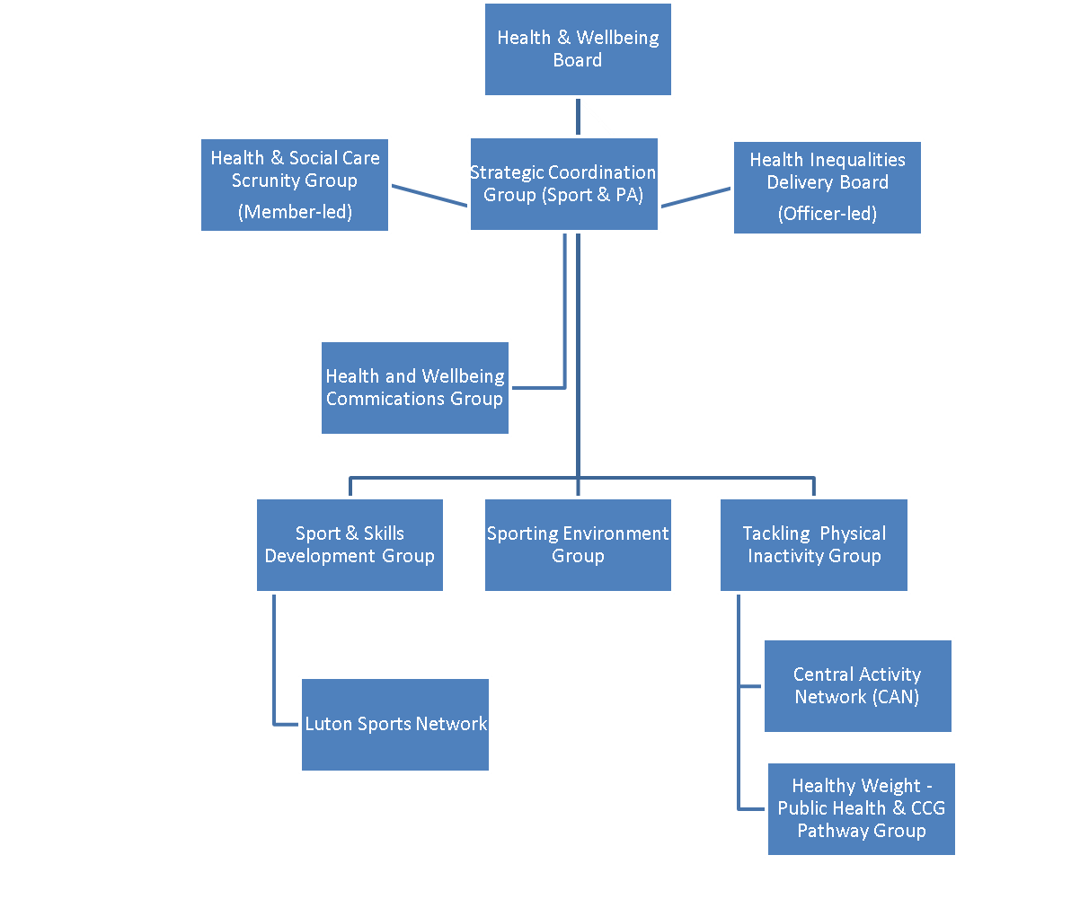

*Figure 7 – Delivery and accountability structure for Luton’s Sport and Physical Activity*

This approach builds on the existing governance arrangements including delivery groups that have been set up to deliver the agreed actions emanating from the Strategic Vision for Sport and Physical Activity in Luton (2013) cited as a model of best practice by Sport England. This approach has effectively:

* Provided a forum for partners who influence the delivery of sport and physical activity within the Borough i.e. bringing the key players together in a structured way.
* Enabled partners to work together with agreed shared priorities that are based on evidence and need to facilitate best use of collective resources available.
* Provided a structure to measure progress on sport and physical activity outcomes for Luton.
* A forum to disseminate information on best practice, local and national strategy, tools and resources or (often changing) local issues.
* Provides a platform for structured investment into Luton, based on strategic priority and need.

In addition to the action plan, local partners are encouraged to use evaluation frameworks such as Sport England’s Evaluation Framework which enables partners to evaluate funding streams and projects consistently, effectively and get maximum value from measurement and evaluation.

Other Social Return on Investment models are also encouraged to be used by partners to ensure the value and impact of sport and physical activity and its wider and cross-cutting outcomes are fully realised to enable the greatest investment into sport and physical activity in Luton.

As part of the evaluation work Luton Council will investigate the opportunity to work alongside the University of Bedfordshire to support measuring the overall five –year impact of the combined partnership activities as outlined within this strategy and action plan.

**Appendix A - *Overview of delivery groups***

| 1. **Tackling Physical Inactivity and Improving Mental Health (delivery group)** |
| --- |
| **Group membership:** Active Luton (Chair), Luton Borough Council (Physical Activity Commissioning, Sustainable Transport, Public Health/Education, Parks, Strategic Community Services), Sport England, Livewell Luton, Team BEDS&LUTON, Sport England, ELFT, Mind BLMK, Luton CCG, University of Bedfordshire, Sustrans, Luton Culture.  **Key responsibilities include**:   * Overall co-ordination of ‘physical activity (non sport)’ based programmes in the Borough i.e. a strategic overview in terms of reporting impact, identifying linkages and opportunities for partnership working and investment. * Joint remit for improving levels of physically active people within the Borough including a specific focus on accessibility to enable those residents to move from doing ‘nothing’ to ‘something’. * To ensure consistent and appropriate messaging around physical activity, according to local need, in terms of alignment with national and local strategy and insight, as well as linking to the joint HWB communications group led by LBC. * Forum to enable join up of mental health and physical activity agenda (i.e. in terms of delivery) * Remit from 5yrs and above, in line with the new Sport England ‘Towards an Active Nation Strategy, however, ensuring critical linkage to the impact and outcomes from the under 5 programme i.e. Flying Start. * Linkage to the wider PE and School Sports Strategy including Primary Premium, School Games, School Health and Wellbeing Awards. * Supporting delivery of the Community Access to Schools project * Provide linkage to planning and active/ sustainable travel to ensure strategic join up with physical activity priorities. |
| 1. **Sport and Skills Development (delivery group)** |
| **Group membership**: Team BEDS&LUTON (Chair), Sport England, University of Bedfordshire, Lawn Tennis Association (LTA), Rugby Football Union (RFU) England Netball, Bedfordshire Cricket, Swim England, England Hockey, Luton Town FC Community Trust, Active Luton, Luton Sports Network, England Golf, Street Games, Beds FA, Dame Kelly Holmes Trust, Luton Borough Council (Physical activity commissioning) .  **Key responsibilities include:**   * Overall co-ordination of ‘sport’ based programmes in the Borough i.e. a strategic overview in terms of reporting impact, identifying linkages and opportunities for partnership working and investment. * Influencing Sport NGB’s to ensure their local support, resources and programmes are reflective of Luton’s socio-economic landscape (and related need) and that this also aligns with local insight and priorities. To work with NGBs to support the delivery of “Core Market” programmes activities with and through local sports clubs. * Related to the above, working with NGB’s to drive participation with regards to key target/focus groups, but with a specific focus on BME women and girls and wider outcomes linked to community cohesion. * Support the grassroots/VCS sports groups, including Luton Sports Network and via the Central Activity Network. * Enabling delivery against the emerging Sport England Volunteer Strategy * Support for town wide workforce development programmes i.e. where sport is the vehicle for personal development (e.g. apprenticeships, sport related qualifications) * Linked to the above, enabling delivery of the new workforce development and coaching plan for England flowing from the new Towards An Active Nation Strategy |
| 1. **Sporting Environment (delivery group)** |
| **Group membership**: Luton Borough Council (Chair – Physical activity commissioning), Luton Borough Council (Parks, Assets, Planning), Bedfordshire Cricket, England Hockey, Team BEDS&LUTON, Bedfordshire FA, Sport England, England Hockey  **Key responsibilities include:**   * Responsible for delivery of actions emanating Playing Pitch Strategy (PPS) and Indoor Sports Facility Strategy (ISFS), including notably the supporting feasibility and funding strategies for the major sport developments required in future in Luton. * Responsible for co-ordinating LBC Community Asset Transfer of sports facilities * To provide linkage to planning frameworks with regards to sport facilities (supporting the process where new sports facilities are provided e.g. new schools, re-provision due to redevelopment for housing). * Responsible for supporting facility rationalisation within the borough, where surplus facilities are identified. * Hold co-ordination role with regards to investment into Luton for Sports Facilities e.g. ensure that NGB’s and VCS has support to develop facilities where they meet priorities as outlined through the PPS, ISFS. |

**Appendix B – Stakeholder Consultation**

A consultation was undertaken to produce this strategy, with input from a range of cross-sector organisations participating in workshops and forums.

In 2017, three specific consultation workshops were held based on Sport England’s participation groups of Inactive, Mass and Core markets, whereby attendees were invited to provide their feedback on how Luton partners can contribute to increasing levels of participation and help shape this strategy.

Attendees included Active Luton (Luton’s Leisure Trust), teamBEDS&LUTON (Bedfordshire’s County Sports Network), Sport England, Luton Clinical Commissioning Group, Sport National Governing Bodies including Bedfordshire Cricket Board and Beds Football Association, the University of Bedfordshire, East London Foundation Trust (ELFT – Mental Health provider), Sustrans, Luton Sports Network and local sports clubs.

There remain stakeholders who to date we are still to engage and there will be a continued process of engagement throughout the life of the strategy to dynamically develop the strategy and action plan. Initially this will be through a six month engagement plan undertaken by the Council’s physical activity commissioning team via a series of ongoing face to face meetings and also utilising the Community Activity Network as a forum for continued dialogue (see page 21).

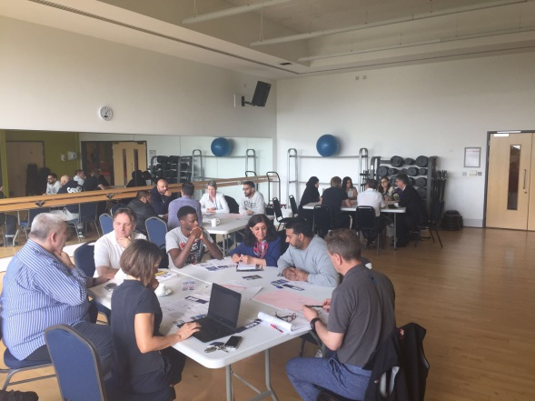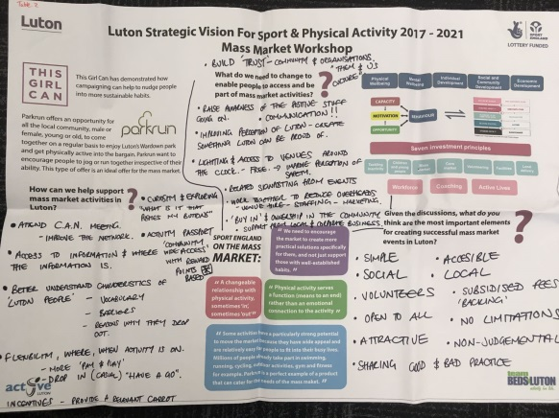

*Local stakeholders providing their views and supporting the production of this strategy*

1. a plural location is defined as a Local Authority area where White British residents do not form the majority population

   2  the IMD is a government measure derived from analysis of seven key indicators (including income, employment, health deprivation and disability, education, skills and training,, barriers to housing services, crime and living environment) and their prevalence within a geographical area