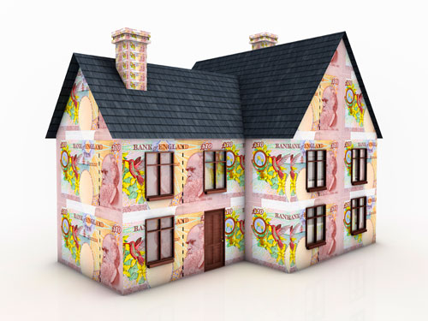

VAT REDUCTIONS FOR EMPTY HOMES

This information is intended for owners of long term empty property within Luton and is to highlight a potential saving for the refurbishment costs of bringing a property back into occupation by a substantial reduction in VAT costs

Two Year Discount
Are you bringing an Empty Dwelling back into use? Can you say yes to the following 3 statements?
- The property has been empty for two years immediately before you start work
- It will be used for residential purposes after completion of the works
- You will be using builders to complete this work
Then you may be eligible for a reduced rate of VAT, currently 5%.
The detailed requirements and eligibility for this concession can be found in HMRC Notice 708. You will need to ensure that your builders understand the reduced rate of VAT rules so that they invoice you correctly.
Ten Year Discount
If you are bringing an empty dwelling back into use that has been empty for more than ten years immediately before the start of works, and will be used by you or your family after the works are completed you may be entitled to zero rated VAT. This concession is included within the scheme for conversions by DIY house builders and the detailed requirements and eligibility can be found in HMRC Notice 431C. If you are completing the building work yourself then no reduction in VAT is available. The recommended approach to achieving the 0% VAT is as follows:
Where you are eligible ensure that your builder first applies the 5% VAT rate to the works which qualify under the two year rule and then complete the conversion claim form in HMRC Notice 431C to recover the 5%you have paid and any other VAT you have incurred in the qualifying expenditure.
Builders may not be aware of the concessionary VAT rates and discounts for residential properties being brought back into use. It is important to ensure that your project qualifies under the rules which are set out in HMRC full guidance in HMRC Notice 708 and/or HMRC Notice 431c and that you can provide all the necessary paperwork. The best evidence that you can give HMRC to support your claim is a written statement from your local Council’s Empty Homes Officer

For further information please contact the Empty Homes Officer on Tel 01582 546370 or email emptyhomes@luton.gov.uk
Luton Borough Council will provide the necessary letter as evidence that a property has been empty for the relevant qualifying period for a fee of £50.

