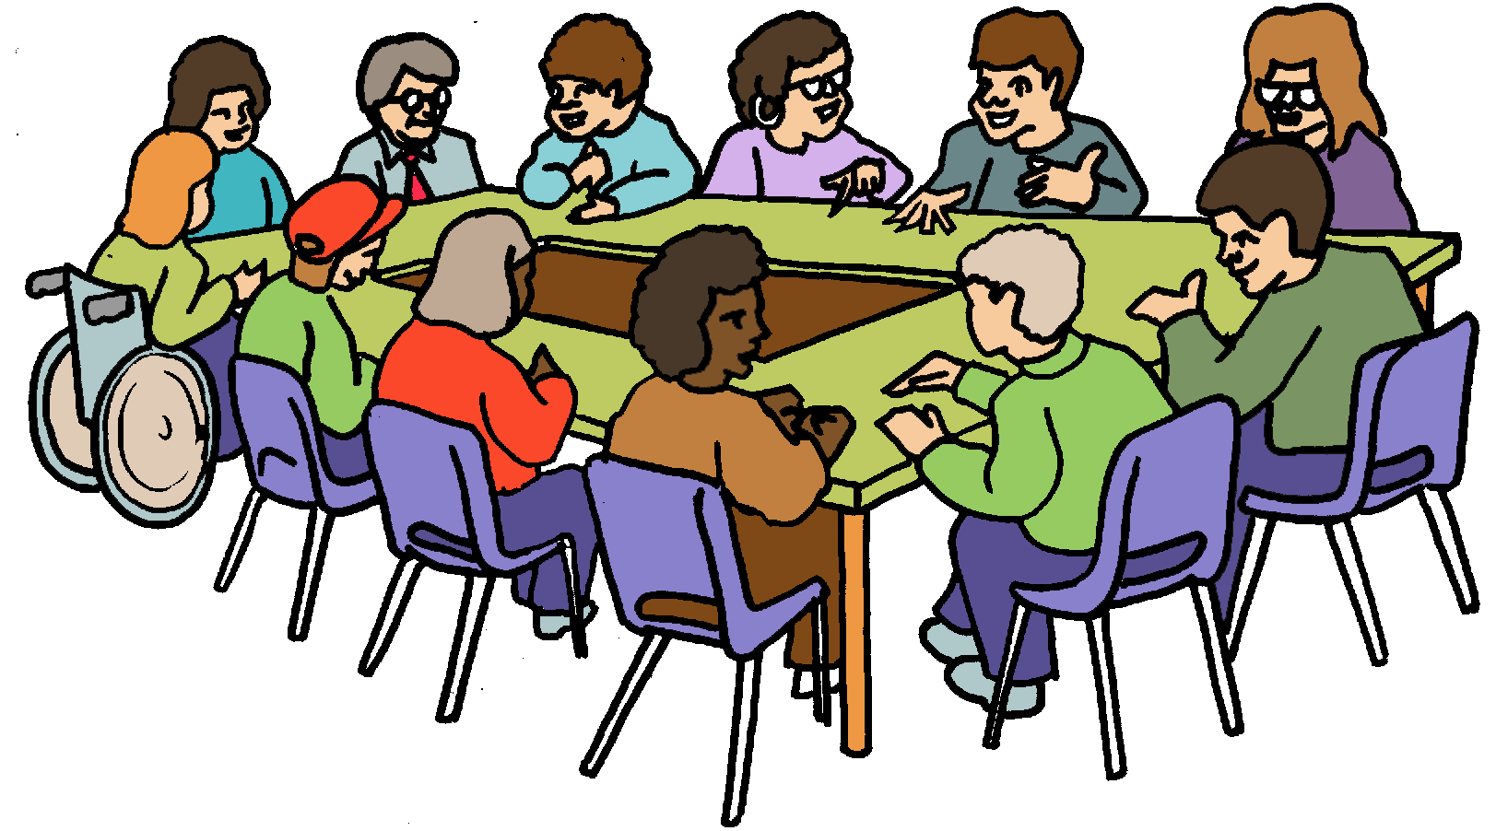

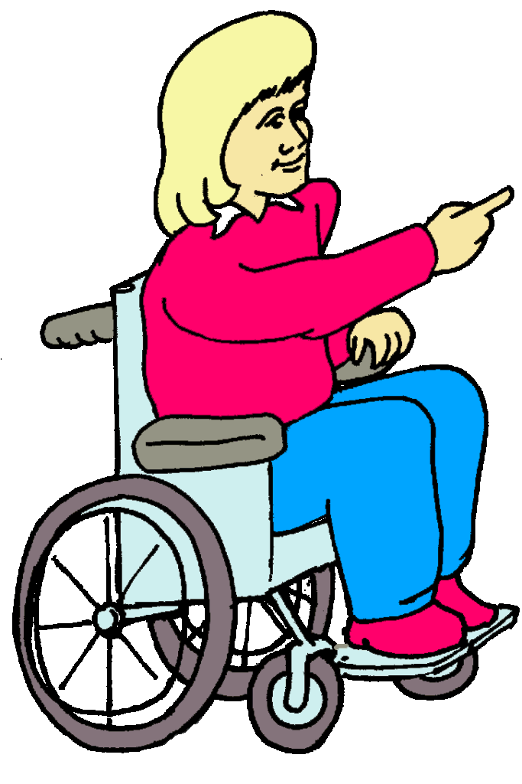







****

|  |
| --- |
| Name of Group/Subgroup: Learning Disabilities Partnership |
| Date & Time: **19th JANUARY 2015**  10:00 – 12:30 |
| Venue: High Town Sports and Arts Centre |
| Who came: Chair; Marisa Rose – LBC-CCG, Co-chair; Sheila Smith – Service User, Tracey Brennan – LBC, Val Sheridan – LBC, Diane Walsh – LBC, Bhavesh – Yawn Life, Jeanette Tennyson – Yawn Life, Jon Wallis – LBC, Mariam Suleman – LBC, Michelle Bailey – LBC, Ginny Conley – LBC, Carly – Yawn Life, James Nettleton – Yawn Life, Yvonne McKinlay – POhWER, Matthew Morley – Yawn Life, Serena Carter –Service User, Stewart Haynes – Yawn Life, Claire Paton – Turning Point, Julie Woodhouse – Yawn Life, Karen Yates – LBC, Hollie – Community Group, Linda Ambrose - LBC, Sam Morrison – SEPT, Paul French – LBC, Carol Newbourne – Macintyre Housing, Glenda Tizard – POhWER, Karen Walsh – SEPT, C. Devonport, Jackie Errington – SEPT, Lorna D – Community Group, Renu Aggarwal – Service User, Janine Macey – Bramingham, Harminder Patel - LBC, Angela Gatwood – Community Group, Alan Fletcher – Healthwatch, Paul McCann – Community Group, Simon Fraser – Mencap, Roger Williams, Berni Doyle – Aldwyck, Upo Hwankwo – Dimensions, Krishan Jokal – Service User, Judith Batson – Parent / Carer, Cheryl Parker – SEPT, Karen Ferguson – SEPT, Edna Edge – Service User, Polly Parrish – LBC, T&N Kinsella, Chris Brandom - LBC, Charlotte Worker – Craegmoor, Tracy Finlan – 1st note, Peter V – 1st Note, Amanda Yearwood – New Horizons, Netra Padiyan – Marlin Lodge, Paul Dunphy – New Horizons, Shima Patel – New Horizons, Dharmindar Kumar – New Horizons, Joanne Wood – New Horizons, Anthony Moran – New Horizons, Sunil Patel – New Horizons, Tom Laurence – New Horizons, M Dhakabai – New Horizons, Diane Humberstone – SEPT, Patsy Trott – New Horizons. Bev McArdle – New Horizons, Alan Tyrrell – Service User. |
| Who let us know they couldn’t make it:  Amy Kay - LBC, Terri Dorman - Sept, Marilyn Orridge - DWP, Carla Mutter - Mencap , Wendy Cook – Central Beds, Sarah Solman – Apex Care, Andrea Nettleton – Parent Carer, Bridget Moffat - LBC, Maud O’Leary - LBC, Pam Scott - LBC, Debbie Poole-Hunt – Luton ACL .  Note Taker: Rose Winter - LBC |

|  |  |
| --- | --- |
| \\corporate\SocServ\Adults\Joint Commissioning\Rose Winter\Valuing People Clip Art; Part 2\Groups, Meetings, and Interactions\Group Staff mixed.gif | **Introductions**  Marisa Rose Introduced herself as the Chair and Sheila Smith as Co-chair. The rest of the room introduced themselves and the minutes from the last meeting were read and signed off as agreed.  Everyone was thanked for attending in such high numbers and it was good to see that there were so many more service users than in previous meetings. |
| **PLAN** | **What the Care Act means for you – Harminder Patel**    See Presentation |
|  | **My role as Co-chair** |
|  | **POhWER Update** |
|  | **Bramingham**  Holly, Paul, Lorna and Angela gave a short presentation, supported by Janine, to tell everyone how they felt before moving into Hightown and now that they have settled. They said that they are very happy to be at the centre at Hightown. |
|  | Tea Break |
| C:\Users\Scott\AppData\Local\Temp\Look_close1.jpg | **Self-Assessment Framework – What we are checking – Val Sheridan and Jon Wallis**  See Presentation:  The people in attendance were asked to vote using cards with red on one side and green on the other, red for No and green for Yes. These were used to answer the questions in the presentation.  There were 67 people in total and this figure can be used to work out the people who chose not to vote.  The results are as follows:  Staying Healthy - A1: Asks if doctors know about people with learning disabilities and that they have them listed on a register. For Luton this has changed from **Red** to **Amber.**  People were asked if they agreed.  **Green** **51** **Red** **4** |
| C:\Users\Scott\Downloads\Amin-3 (1).jpg | Staying Safe - B2: Making sure that those who support people with learning disabilities where they live are doing what it says in their contracts. For Luton this has changed from **Amber** to **Green**  People were asked if they agreed.  **Green 52 Red 1** |
|  | Staying Safe - B3: Doing what ‘Monitor’ says the hospital should be doing. For Luton this has changed from **Amber** to **Green**  People were asked if they agreed.  **Green 47 Red 5** |
| C:\Users\Scott\Downloads\Planning-Meeting-4.jpg | Staying Safe - B7: We make sure we are planning and buying the right services for people with learning disabilities and we have a plan for this. For Luton this has changed from **Red** to **Amber**  People were asked if they agreed.  **Green 59 Red 1** |
| C:\Users\Scott\Downloads\Care-Choices.jpg | Living Well - C7: People with a learning disability and families get involved in making decisions about services. This is a new question and we said that Luton is **Amber**  People were asked if they agreed.  **Green 58 Red 0** |
| C:\Users\sheridav\AppData\Local\Microsoft\Windows\Temporary Internet Files\Content.IE5\7V90FFLN\green_globe_ok_tic_584[1].jpg | We then asked people if they thought that using voting cards was a good way of knowing peoples’ answers.  **Green 44** **Red 7** |
|  | **Business as Usual – Tracey Brennan**  See Presentation; |
|  | **Subgroups or Task and Finish Groups?**  It was suggested that in the future perhaps instead of subgroups we should hold task and finish groups, which concentrate on specific issues.  There was concern about if this could mean extra meetings and how the information would be collated. This shall be looked at again, discussed and feedback recorded.  The next set of subgroups will go ahead. |
|  | **Any other business:**  It was suggested that if more information could go out with the agenda then support staff could help service users to understand the topics and prepare more before the meetings.  Tracey said she would discuss this with the executive. |
| **Date & Time agreed for next meeting:**  **4th June 2015**  **1pm till 3.30pm**  **To be held at: Hightown Sports & Arts Centre** | |
| If you have any pressing issues that need to be discussed before the next group/subgroup meeting please contact the chair person | |

­­­