How do you rate me?
Good ingredients, good cooking, good health
We aim to provide you, valued customer, with food bought from reputable suppliers, stored correctly and handled hygienically.
We work with Environmental Health at Luton Borough Council to ensure we keep the highest standards.
While we prepare your order, please note how we work to give you a quality, wholesome product.
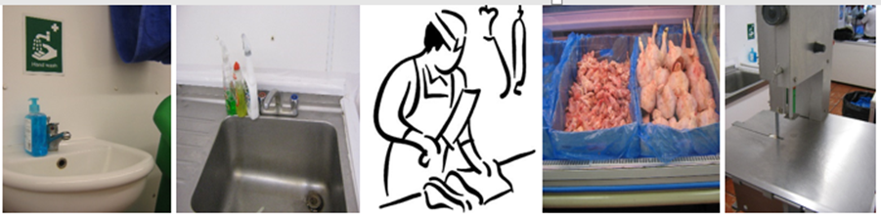
We want you to notice our hard work- this is what we aim to do:

1. Train our butchers in food hygiene - their certificates are on the wall.

2. Buy from suppliers we trust - ask us who they are if you like.

3. Supply you with meat that is fresh and has been delivered recently - ask us when if you wish.

4. Keep this area clean and disinfected:
-use detergent and disinfectant
-use hot running water
-use paper towels because they are less likely to transmit bacteria.

5. Check our fridges regularly to ensure we are keeping your meat at the right temperature.

6. Wear a clean uniform every day and only use them in the butchery area. They may get stained during the day but we will wash them every night.

7. Behind the scenes we will keep meat away from fruit, vegetables and other food. It’s safer that way.

Food must be handled safely at all times - it’s the law and we follow it.



