Band saw safety
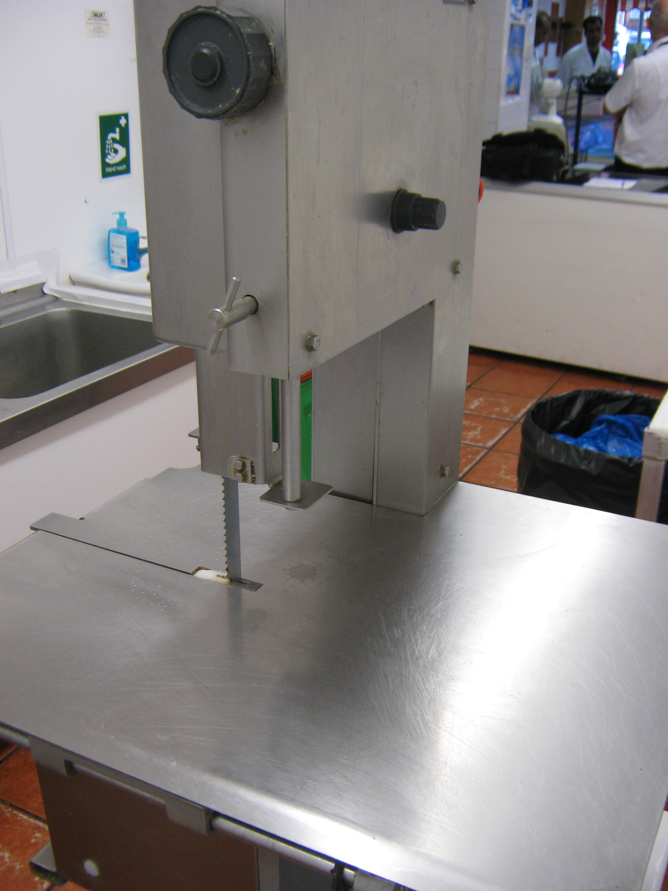  Do |  | Don’t
Use the right machine  for the job and train your staff how to use it safely |  | Let someone untrained use the machine
Ensure the machine automatically shuts down when the guard is removed.  During cleaning use a blade carrier if removing the blade |  | Allow minors to operate the machine  Leave the machine plugged in during cleaning
Ensure the electrical wiring is in good order and the emergency stop button is working |  | Place the machine where your customers can access it or in busy people traffic areas
Inspect and maintain  the machine regularly |  | Use the machine if it is damaged
When cutting meat ensure a guard covers as much blade as possible |  | Wear loose fitting clothes when using the machine
Ensure the saw is safely  mounted and does not  rock or move |  | Leave the machine unattended when running or distract staff when they are using the machine
Only use blades advised  by the manufacturer  Use a pusher or a jig where possible to keep hands away from the blade |  | Disable the interlock  Leave wires trailing where people are walking
For further advice on band saw safety see www.hse.gov.uk/pubns/priced/pm33.pdf

For further advice on food hygiene, health and safety see http://www.everythingregulation.org.uk
If you require a copy in large print, on tape or in a language other than English such as Polski or  please Telephone 01582 501330


